Advancing Precision Medicine by Breaking Down Information Silos
November 2019

Karan Cushman: Welcome to the The Precision Medicine Podcast, sponsored by Trapelo. This is the podcast where experts come to discuss the problems oncologists, reference labs and payers face as precision medicine grows, and consider solutions for advancing the quality of patient-centered cancer care. Be sure to subscribe at precisionmedicinepodcast.com to get the latest episodes delivered straight to your inbox.
Jerome Madison: Welcome to another episode of the Precision Medicine Podcast. I'm Jerome Madison, Vice President at Trapelo. Today we have Kristine Ashcraft, CEO of YouScript. Thank you for joining us for the podcast.
Kristine A.: Thank you so much for having me, Jerome.
Jerome Madison: For sure. Give us a little bit of your background and your vision of how you created YouScript.
Kristine A.: Sure. I have been in the precision medicine space, specifically pharmacogenomics, for about 20 years now. Actually started my journey at a lab, Genelex, that was originally started in 1987 as one of the first crime labs in the country with a National Institute of Justice Grant.
Kristine A.: When I joined in 2000, they were looking for something that leveraged their core competency in providing high quality genetic testing. And way back then, there was an article in Fortune Magazine about a boy named Michael who had died of an overdose because, like 1 in 20 patients, he had a DNA variation that in concert with his other medications made his drug unsafe for him.
Kristine A.: So, like good molecular biology geeks, we went to PubMed and started looking at just how common these variations were, how many drugs they impacted, and became one of the first CLIA accredited labs to provide that testing. And naively thought because of the level of information it would be standard of care in five, six years, tops. But did learn an awful lot and started down this path, I think that is a fairly typical, of initially providing a PDF report. What we saw is that the knowledge was advancing so quickly that that quickly became outdated. It also didn't take into account other medications that the patient was taking.
Kristine A.: In the early 2000s, I was lucky enough to stumble across a software program that had originally been created by a couple of brilliant psychiatrists that ran into cytochrome-based drug interactions. Those are the same cytochromes we do genetic tests for. And because of the way they had designed the program, we were able to upgrade this software to detect genetic interactions as well and started providing that as a web-based tool. Of course, if you work much with physicians, you know what they said next: "That's nice. Put in my clinical workflow, or I'm not going to use it."
Kristine A.: I realized in 2016 that we were getting closer to a tipping point for pharmacogenomics and for pharmacogenomics to really scale, a tool like YouScript needed to be in the clinical workflow. Needed to flag when a patient needed to be tested and also provide real time information on how to optimize drugs and doses.
Kristine A.: So, we spun that technology out of the lab, and we're now embedded in the workflow in Epic, Cerner, Allscripts, and are working to really make sure that that information is used not just once when a PDF report comes out, but anytime a medication decision is made the rest of the patient's life.
Jerome Madison: I think that's incredible. When you were sharing the story of how you aid physicians in getting this information to make better treatment decisions, I thought it was fascinating.
Jerome Madison: The title of your talk—when I heard you speak at The Precision Medicine Leaders’ Summit in San Diego—was Lessons Learned from 20 Years in Precision Medicine. I think it's a good place to start, because one of the lessons that slapped me over the head was in order to move precision medicine into routine clinical practice, we must increase physician knowledge and belief about genomic medicine.
Jerome Madison: I've never heard it quite stated like that. We tend to assume that physicians know this, or know how to use this, and that's the knowledge part. But it's for those who've been in the industry for quite a while, we know that it's really more of the belief that it actually helps. Where are we now, and how far do we need to go?
Kristine A.: Well, if you're familiar with the adoption curve, I would say we are now on the start of the early majority, which is an improvement. When I first started talking about pharmacogenomics with physicians in 2000, they said, "Pharmaco what?" I don't get that anymore.
Kristine A.: People are certainly aware of genomics and pharmacogenomics in terms of knowing it's a thing, and it's out there. I think that Obama's Precision Medicine Initiative really helped in that arena. But there was a survey that just came out recently that 23% of physicians said that they had comfort talking about genetics as a risk factor. That means three quarters did not feel comfortable, but when they had personal genetic testing, that jumped to 59%.
Kristine A.: We're seeing a lot more direct-to-consumer genetic testing and a lot more health systems that are doing comprehensive genetic testing, like Geisinger for example. I think we're getting there, but we still have a long, long way to go.
Jerome Madison: One of the Chief Executives from one of the major gene sequencing... Not gene sequencing companies, but those that make the platform, he made a bold prediction that said within five years, pharmacogenetic testing will be routine; it's just going to be a normal part of the workflow. And if it wasn't for the fact that I heard this 5, 10, 15 years ago, I would be more enthusiastic about that. What are your thoughts around us being there in five years? Because we do have the tools that can put it at the point of care.
Kristine A.: Right. I think two big things that make that possible. One, the cost of pharmacogenomic testing and genomic testing has come down dramatically. When we first started offering pharmacogenomic testing, it was $1,000 to do a comprehensive panel. It costs under $200 to do a comprehensive panel now. That's going to continue to come down.
Kristine A.: We now also have the tools to flag patients for appropriate testing and provide real-time, clinical decision support on how to act on that information in the clinical workflow. We're also seeing, at least in pharmacogenomics, expanded coverage. United Healthcare issued a coverage decision that went live October 1st covering psychiatric panels. Most of the Medicare Max, Palmetto, Noridian, CGS have issued draft, local coverage decisions that dramatically expand coverage for pharmacogenomic testing.
Kristine A.: So, I think that we are definitely moving in that direction, and what that enables us to do is really validate at scale that this keeps patients from having adverse drug events that put them in the hospital, that put them in the emergency room. We've published some studies and in one we saw a 71% reduction in ER visits and 39% reduction in hospitalizations. I think as more and more clinicians see the impact this has on improvement in patient care, the more widely that will be adopted.
Jerome Madison: I think that's tremendous. One of the other lessons that you said you've learned, out of the many, I can't pick them all, Kristine, but the highlights for me, you said that we must prevent disease silos because disease silos prevent progress, and, in some cases, create harm. Can you tell us a little bit more what you mean by that?
Kristine A.: Sure. A lot of the pharmacogenomics testing historically focused on drug gene pairs and even some of the coverage decisions now, or by disease, like psychiatry, like I just mentioned. The issue is that these pharmacogenetic markers impact drugs across all disease states. Part of the reason behind that is that's how you get reimbursed. You pick a disease, and you show that you can impact some outcome associated with the disease, and that's how you get reimbursement.
Kristine A.: The issue is, for pharmacogenomics, and genomics in general, for germline genomics, that information isn't going to change the rest of the patient's life. It's not just for that drug gene pair or that disease.
Kristine A.: You take Plavix for example. Plavix is often given for patients that have had a heart attack or stroke to prevent them from having another one. Plavix doesn't work for you if you're a 2C19 poor metabolizer.
Kristine A.: We just did a quick analysis in our database and said, well, how many patients on Plavix had another 2C19 medication that had a significant interaction? 20%. 60% had a significant interaction for another gene.
Kristine A.: If you just focus on these pairs or on these disease states, you're missing the impact that that can have across the entire patient, because they're not just a psychiatric patient, they're not just a cancer patient. They're a human that has cancer and often depression, pain, comorbidities like heart disease. And, so, if you're dealing with genetic information, you need to make sure that that's applied anywhere it's going to impact that patient's care.
Jerome Madison: So, in large part, it really is going to require a paradigm shift, not only in healthcare but from the individual provider, because they think in terms of silos, because I am a left ear specialist and this person is a right toe doctor. And for years the conversation with precision medicine is being treat the patient, not the disease. Look at the molecular expression and see what information can help us make better and more effective treatment decisions. But what do you hear with respect to providers out there adopting that type of mindset?
Kristine A.: You're correct, it's a paradigm shift. We're moving away from here is how we treat this disease, option one, two, three, to here is the best course of action for this N-of-One patient. And, so, it is going to be a retraining. I think that pharmacogenomics, for example, is required in pharmacy schools now. Genomic education is expanding in medical schools now. A number of health systems are providing continuing education around genomics. But we do have to shift the way that we think about how we provide care. It's not going to be easy.
Jerome Madison: Do you go into hospital systems or healthcare networks to do education around this?
Kristine A.: I sure do. I actually was recently invited to give the keynote for the Medical College of Wisconsin's Genomics Conference. As part of YouScript deployments, when we integrate into a health system, we send a team in including some of our clinical pharmacists to train the trainer and walk through not just, hey, here's this clinical, decision-support tool, but here are all the steps you need to take to integrate this as a program to optimize medication in your health systems. You can't just toss technology at people. You have to go through the steps of the change management and training as well.
Jerome Madison: For sure. One of the more important lessons that you mentioned is that it is important to prioritize EMR integration. I think, Kristin, we could probably do just one conversation or podcast just on that alone, but you had a lot in that. I know your talk was only so long, but why is it important to prioritize EMR integration of this information?
Kristine A.: Sure. Well if you think about it, historically lab results, it wasn't the worst thing if they were misplaced, because you would just do that lab again. But when you're talking about genetic information, especially germline genetics, that information isn't going to change the rest of your life. That lab result needs to be re-accessed any time it will impact your care.
Kristine A.: One story that I heard when I was speaking at a State of Reform Conference in Hawaii, which is healthcare policy and reimbursement conference, this woman came up to me afterwards, and she's like, "I had a patient who had this psychiatric pharmacogenomic testing done. She was a 2C19 poor metabolizer, and so it said which psychiatric medications probably wouldn't be a good choice for her. Thankfully, I knew that she shouldn't be on Plavix, which has nothing to do with this depression report."
Kristine A.: So, ideally if you have this information integrated into an EHR, you can alert people when a patient is on a dangerous medication or beyond pharmacogenomics if they have higher risk for certain diseases. But the first step there is prioritizing the discreet storage of the information so you can provide real time clinical decision support.
Kristine A.: I think the other key thing about EMR integration is that the technology is advancing so quickly—our understanding of this is advancing so quickly—that you have to have access to real-time evidence.
Kristine A.: I was actually chatting with my friend Luke at Optum the other day, and they had one of their pharmacists look at a publication on the evidence around pharmacogenetic genes for psychiatry that was published one year ago, and a lot of it was already outdated. There were a number of genes that are now considered clinically actionable that weren't a year ago. So, if you don't prioritize the ability to deliver real-time, clinical decision support on that quickly evolving evidence, it's going to get outdated quick.
Jerome Madison: One of the big conversations at this past ASCO was we need to be more interconnected with the way that we share our data. The analogy that was used is, we can travel anywhere in the world and we can access our investments, we can access our bank records, some of the most intimate details of our life. We can't even access our own healthcare records.
Jerome Madison: The argument has been that the sensitive information, especially around genetic or genomic information, the healthcare systems hold it close to the vest. There is a debate around who owns the data. The lab says they own the data, the healthcare system owns the data, but recently a representative from CMS said that's a big misunderstanding. It's the patient's data.
Kristine A.: That's correct.
Jerome Madison: How can we better facilitate? You're talking about a tipping point in a paradigm change, how can we better facilitate this conversation with healthcare systems to help them understand that it's important for EMR integration, but also to make that information accessible.
Kristine A.: Well, I think they're going to have to, whether they want to or not. The Office of the National Coordinator is pushing to make that mandatory, that the patient will have access to that information.
Kristine A.: I've always wondered, and I'm not the expert, why we don't have a patient identifier nationally. You had to go sign up for your social security number at one point. Why don't you go sign up for your patient ID? So, we don't have this problem with matching patient records across systems.
Kristine A.: But I think it's highly important that that information be available and go beyond the walls of different health systems. I went in to the doctor, I was just in the doctor yesterday getting my flu shot, and they said, "We want to give you a tetanus shot, too." And I was like, "No, I had one of those three years ago." But it wasn't in their electronic health record because we switched health plans, and I have a different doctor.
Kristine A.: But that's a simple thing. It probably wouldn't have hurt me to have another tetanus shot, but more important things are getting missed all the time because we're not sharing patient information the way we need to.
Jerome Madison: In addition to the EMR integration, I think even further upstream is the ability to deliver and store data discreetly. You talk about that. How can that in the big picture of things help the precision medicine ecosystem?
Kristine A.: I think historically we've looked at prospective randomized control trials as the gold standard. The issue is, they're so tightly controlled that you don't see what the impact is in the real world. If we have repositories of genomic information, and we've taken down these siloed walls for patient information outcomes, dosage, what drugs worked, what drugs didn't work, and are able to amass all of that information. That's the only way we start getting to this N-of-One that we talk about where we can truly optimize things.
Kristine A.: We need to be able to put machine learning and artificial intelligence layers on that, so we can get more and more precise in terms of what treatments are going to work for what people. But the first step in that is really making all of that data safely available for analysis.
Jerome Madison: You talked about what it was going to take to really bring this information forward in the words “routine practice,” and you mentioned the payers. How do you think the delivery of discrete data will help payers become more receptive to paying for these tests?
Kristine A.: Right. I think that one of the things that's interesting again about genomic information is that information can be used throughout a patient's lifetime to optimize care in a lot of different situations.
Kristine A.: Ideally, you would only pay for a robust pharmacogenomic panel one time, that information would be stored discreetly, and then used going forward to optimize drug and dose selection. There was a study that came out last year that put the cost of non-optimized medications at $528 billion. That's more than we spend on the drugs themselves or any major chronic disease.
Kristine A.: If we do a better job of that, it'll dramatically reduce that number and also improve patient outcomes. I think everybody has a story, either a personal one or a friend or family member that has had either a bad reaction to a medication or had a medication not work for them. And that's just in the silo of pharmacogenomics.
Kristine A.: But if you don't have that information stored discreetly, there's nothing stopping…especially with patients like me that have to move health insurance every few years. All employers are shopping that because it's a big expense. Those tests can get ordered again and again. If you put the infrastructure in place, you're able to avoid that and also make sure that the patient's care is optimized based on the information.
Jerome Madison: Well, I love what you're doing. I love to hear you talk. Very engaging. You've been at this for quite a while on the entrepreneurial side building this company. What keeps you motivated in driving?
Kristine A.: It's the patients. I still get emails from some of the patients, and I do miss actually talking directly to patients as I did way back in the early days. But one woman in particular, Elise, they thought that she had Alzheimer's, and she actually had a drug gene interaction that, when resolved, made her “Alzheimer's” go away.
Kristine A.: At the end of the day, it's the right thing to do for patients and it makes a huge impact on quality of life. I'm not ending, I'm not stopping until avoidable, adverse drug events are a thing of the past.
Jerome Madison: That's it. That's incredible. Well, we thank you for the work you do, and I know the patients who are benefiting from this do as well. We need more thought leaders like you to move that conversation forward with the right folks. We applaud the work you're doing, and thank you for being a guest on the Precision Medicine Podcast.
Kristine A.: Thank you so much, Jerome. Really appreciate it.
Karan Cushman: You've been listening to the Precision Medicine Podcast sponsored by Trapelo. Trapelo is the first clinical, decision-support tool to align the interests of oncologists, labs and payers to give patients the best chance at beating cancer. To learn more, visit gettrapelo.com. To subscribe to the podcast or download transcripts of any episode, visit precisionmedicinepodcast.com.
Karan Cushman: We invite you to join the conversation on social media. You can find us on Twitter at PMPbyTrapelo or on LinkedIn at the Intervention Insights’ company page. If you know someone who would enjoy the Precision Medicine Podcast, please share it. They'll thank you, and so will we. We hope you'll tune in for the next episode.

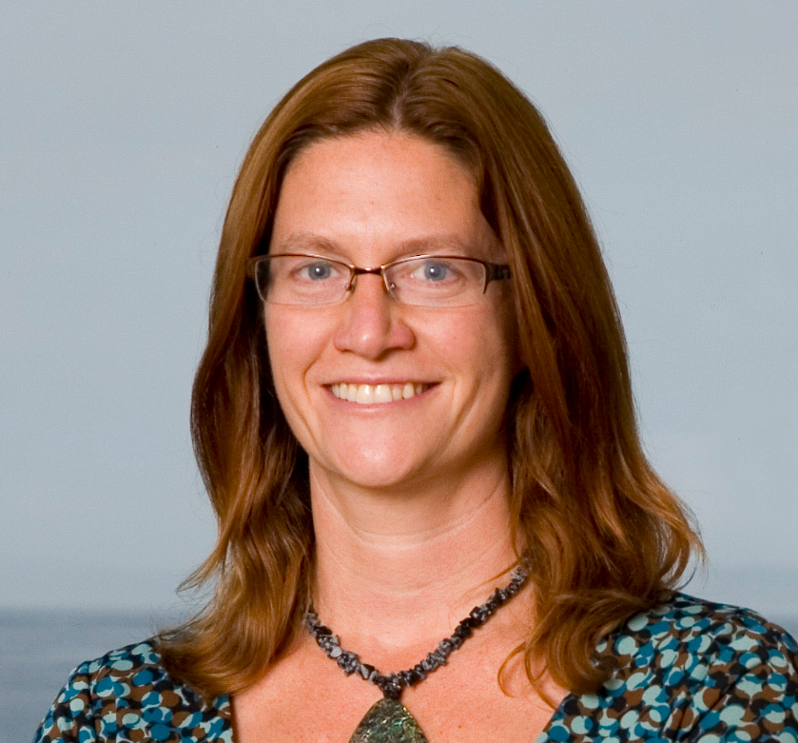
About Our Guest: Kristine Ashcraft, B.S., MBA

Kristine Ashcraft, B.S., MBA is a molecular biologist by training and is CEO and founder of YouScript. She has worked in the precision medicine space since 2000 and was recently named one of the 25 leading global voices in precision medicine.

Kristine has authored multiple publications on the clinical and economic benefits of pharmacogenomic testing, including one lauded as one of the most influential publications at a recent AMIA meeting. She has been interviewed by numerous media outlets including the New York Times, the Wall Street Journal, and NBC Nightly News.

Kristine has spoken at SXSW, ASHG, and numerous Precision Medicine Conferences. She is committed to being a catalyst in the adoption of precision medicine.

Connect with Kristine:
On Twitter at @YouScript and @Kristine1c
On Linked In: https://www.linkedin.com/in/kristineashcraft/
Website: https://youscript.com/

