EPISODE 15:
Precision Oncology and the Science of Racial Disparities: Two Researchers Discuss the Importance of Identifying Differences
Dr. Windy Dean-Colomb and Dr. Clayton Yates
Welcome to The Precision Medicine Podcast, where experts come to discuss the problems oncologists, reference labs, and payers face as precision medicine grows, and consider solutions for advancing the quality of patient-centered cancer care.
Jerome Madison: Welcome to the Precision Medicine Podcast, where experts come to discuss the problems oncologists, reference labs and payers face as precision medicine grows and consider solutions for advancing the quality of patient-centered cancer care.
Welcome to the Precision Medicine Podcast. I’m Jerome Madison, host of the Precision Medicine Podcast, and today we have Dr. Windy Dean-Colomb, an MD Anderson trained MD, PhD and practicing medical oncologist. And we also have Dr. Clayton Yates, a professor of biology at Tuskegee University and director of the university’s Multidisciplinary Center for Biomedical Research. And, today we’ll be talking about disparities in precision medicine and one of the recent publications on a significant breast cancer subtype that is not typically discussed. So Windy, Clayton, thank you guys so much for taking time out to be on the Precision Medicine Podcast.
Windy D-Colomb: Thank you for having us.
Clayton Yates: Yes, thank you very much.
Jerome Madison: Windy, first let’s jump into your background a little bit. Can you tell us what attracted you to oncology and why your research interest in breast cancer?
Windy D-Colomb: Well, I’m from Louisiana. And unfortunately, despite all the great things about our food and everything else, women in Louisiana have the second-highest level of women dying from breast cancer across the United States. So that was a big concern for me. Why are more women in Louisiana dying of breast cancer? And so that started my journey to figure out why. That was my focus, in cancer. But more specifically, we also know that African-American women in Louisiana die more frequently of breast cancer, making them number one in the country as far as the number of women that die of breast cancer. So, that really prompted my interest in cancer, but also because of a lot of family member having other cancers, I wanted to try to understand that process better so that I could give better care to patients.
Jerome Madison: So, Clayton, why did you pursue a PhD, and how did you become a researcher at an HBCU, historically black college university, at Tuskegee University?
Clayton Yates: Right. So, I actually attended Tuskegee as an undergraduate. And at the time, my grandfather, right before I started Tuskegee as an undergraduate, my grandfather passed away of prostate cancer. I wanted to understand why. So, I volunteered in the lab here at Tuskegee, and I just was very taken about being able to ask questions as to why and hopefully be able to come up with solving problems. And so, after Tuskegee, I went to University of Pittsburgh where I completed my graduate work. I was continuing some of the work that we were doing here at Tuskegee on prostate cancer. And every time we would write a journal article or write about prostate cancer, we would say that African-American men had 60% more incidents and twice the death rate. But after that statement, which would be the first two lines of every article, there was nothing else done about it. And so, during that time, when I was to graduate school, I decided that I wanted to focus on that particular issue. And so, after making that choice as far as a career focus, there was no other place that I wanted to come to other than Tuskegee to actually do this work.
Jerome Madison: That’s awesome. That’s awesome. When we talk about disparities with respect to disparities in cancer, lung, and colon cancer are the most common cancers developed by both men and women, but the most common cancer for each gender is what you guys specialize in. Clayton for you, prostate cancer. And Windy, breast cancer for you, which you are both well published in those areas.
Clayton, Tuskegee is one of only seven research centers at minority institutions that is funded by the National Institute of Minority Health and Health Disparities. They get grants. And for those of you listeners who may not know, Clayton was one of the first speakers at the National Cancer Institute that talked about disparities and the biology of prostate cancer. You just mentioned that African-American men have the highest incidence and poorest outcomes. And through your work of working with the National Cancer Institute, you guys were awarded an $8.5 million NIH grant. That’s pretty fantastic. Can you tell us about your research in prostate cancer and how the grant is going to empower you and your team at Tuskegee to further your discovery efforts?
Clayton Yates: Well, yeah, definitely. The grant is a culmination of a focus that we’ve had for many years here at Tuskegee since I started. And even before I started, Tim Turner and Roberta Troy laid the foundation for us to really start answering ... asking and then hopefully trying to seek answers to questions as to why minority populations are affected by disease more than others. We thought ... or in particularly from my view, Tuskegee should be a lead institution given its historical presence in the community and the work that we have begun through funding through the NCI as well as now the National Institute for Minority Health and Health Disparities will enable us to really start understanding the molecular events, molecular genetic- and epigenetic-drivers that seem to be pervasive in aggressive tumors in African-Americans.
Clayton Yates: And prostate cancer obviously has been a major focus of mine and a lead focus of our laboratory. But with this funding, now we are extending to other tumor types as well. And then also allowing for…the funding allows for us to now disseminate these findings out to the community. So, it’s a multi-pronged approach where our discoveries are rapidly translated to community. We host town halls where the community is engaged. It helps inform us what their particular needs/concerns are as we’re moving forward, because obviously this research cannot be done without the community. And so, we have this dialogue and feedback that is being exchanged that is really helping shape the focus of what disparities research and hopefully answers that the community desperately needs going forward.
And so, the last part of the grant is also to give opportunities for young investigators to have an opportunity to pursue a career in disparities, because, as you probably noted at the beginning, disparities is a new field. It’s a relatively new field, particularly in the area of biological sciences. And so, the grant provides seed money for young investigators with great ideas here on campus to now be able to pursue those, to leverage those into an extra-mural or larger funding grants and hopefully have the same impact that we’ve had in prostate cancer over the years.
Jerome Madison: Yeah. Windy, likewise with African-American women with breast cancer, there are disparities across the breast cancer-continuum. Even starting with prevention and detection, data shows that African-American women don’t get mammograms at the same rate and there is a delay in starting treatment, even though there is information out there that researches have brought up of the dynamics of nature versus nurture. Nature meaning the genetic aspect of predisposition to cancer versus nurture. And you just spoke about them earlier, those social determinants being maybe poverty or low economic status that hinders access, then diet and exercise. And then there’s an issue of social injustice, which we’ll get to in a minute, and I’m kind of saving that for Clayton. And we’ll also talk about those genetic findings momentarily. But can you share what you see in your practice every day of why African-Americans may have worse outcomes in breast cancer and how these social factors impact those outcomes?
Windy D-Colomb: Yeah. Well, we definitely know. As you indicated, there’s a lot of data that supports the disparity that we see in breast cancer outcomes for African-American women. So that’s very clearly delineated. Now, the cause of disparity in African-American women is multi-factorial in origin. Some of it has to do with—and probably a large part of it depending upon what part of the country you’re in, but especially along what we call the black belt, which is Louisiana, Alabama, Mississippi—lack of access to care has become a big problem and the Affordable Care Act has made that better for sure, the lack of access care. But even when they have insurance and they make it to the doctor’s office, then oftentimes patients are still not referred for mammograms and other things that they need to have done. And studies have shown that even in that situation, because of the socio-economic status, because of what some people may call covert racism, it’s just that doctors also don’t refer patient out for the standard screening on a more regular basis as they should. And part of that has been shown to be related to what zip code they lived in and their socio-economic status.
Windy D-Colomb: But the studies have shown that once patients are referred to mammogram, most of them are usually adherent. And, actually, studies have shown that over the last several years, the number of women that are increasing their use of mammograms at a higher level has been African-American women. So, when the referral is done and they have access to care, then a lot of those women will be adherent to the guideline recommendation of getting your mammograms once a year or twice a year, whatever guidelines they’re following.
So, when we try to address those kinds of things, we still know that a disparity exists, and that has to do with our genetics and our…the impact of the environment that they live in. Because even when studies have looked at African-American women that are in the military, their outcomes are still worse, but yet they have the same access to care as their Caucasian counterparts. So, there has to be a biology component, and unfortunately until recently in the last couple of years, no one really did any research to address that issue.
So, in my clinic, I see young African-American women coming in with breast cancer. And a lot of those women that are coming in are below the age of what is considered standard-of-care mammogram screening. So right now, if you look at the U.S. Task Force, the age is 50. Well, most of these young women that are coming in with these aggressive breast cancers are less than 50. They’re on the average age of 45, so they’re not going to be women who are going to be found by a mammogram because they’re not in the age of the current guidelines. And so, oftentimes when they come in, they are at a later stage. And then they have this more aggressive, triple-negative breast cancer, which the studies have shown there’s a higher percentage of young women that develop this triple-negative breast cancer, which is the most aggressive cancer subtype that we have. So, that kind of prompted my interest in focusing my research in triple-negative breast cancer and what can we do about that.
Windy D-Colomb: What I want to do as a physician is not only be able to see patients and take care of patients, but make sure that I’m giving them the most appropriate care for their cancer. And the only way I can do that is to understand their biology. And the only way I can do that is if we have people like Dr. Yates, who’s doing the translational research that we need, in particular focusing on these at-risk populations. So, I think the way that we’re working together interweaves what we’re finding in the lab, being able to translate that to the clinic is going to be the important part of addressing the disparities that we see.
Jerome Madison: Yeah. I think the major study that came out, one of the most notable studies in 2018, was the TAILORx trial. And Windy, everything that you’re speaking of was echoed in some of the findings that came out of that study. And for those of you who may not be readily familiar with TAILORx, it was an international phase-three study that enrolled over 10,000 women with HR positive, HER2 negative breast cancer. And it found that African-American women with the same breast cancer subtype as white women have worse outcomes. And to be sure, they took as much of the social determinants out of this study as could be. That means the same quality of physicians, the same types of therapy, and the same follow-up. And what was found is that African-Americans with the same type of disease had a 39% increase in risk of recurrence and a 52% increase in risk of dying from their disease.
In fact, the lead author, Dr. Kathy Albain, talking about this particular subject at San Antonio Breast Cancer Symposium last December said, and I quote, "These findings add to emerging evidence that biological basis with or without other factors may contribute to racial outcome disparities in hormone receptor positive breast cancer." Well, obviously this is not news to you guys because this is the work that you’ve been doing for years, and it speaks to your studies.
So, I wanted to get into the papers that were recently published, that you guys were authors on, that revealed a unique immune signature that would allow you potentially to identify African-American women at risk several years earlier. And then another study that emphasizes the importance of quadruple negative, and I think you’ve already mentioned that. Windy, can you share what you and your collaborators found in your studies and how it can help address breast cancer-related disparities?
Windy D-Colomb: Yes. So, one of the things that I have focused on is triple-negative breast cancer. And what triple-negative breast cancer means is that those patients who have breast cancer are negative for the estrogen receptor, the progesterone receptor and HER2. And those are the three molecular markers that we use to guide our treatment for all breast cancers. So, that’s one of the first steps that we do to be able to determine what kind of treatment persons can get. But more importantly, that information also gives us prognostic information as far as how well a patient will do with their breast cancer, alluding to what you were saying earlier, the risk of recurrence, the risk of death. And what we noticed for triple-negative breast cancer, patients with triple-negative breast cancer have the worst survival when compared to their counterparts with estrogen-receptor positive breast cancer or with HER2-positive breast cancer. And, unfortunately, the only treatment we have for this cancer is chemotherapy. So, we don’t have any of the targeted therapy.
Windy D-Colomb: And so, what we were seeing was that…I was sharing with Dr. Yates. I said, "One of the things that I see with these patients is that when they have the triple-negative breast cancer, they differ. There are some of them that do better with their triple-negative breast cancer, and some of them that do worse. And the thing is, it’s hard for us to tell which one has the bad player. But the problem is that we treat them all the same. It’s the same chemotherapy drugs for everybody. But clearly that is not the answer, because some people will develop recurrent disease within two years and be dead within three years. So, something is different, but we’re giving them all the same treatment.
Windy D-Colomb: So, I was sharing with Dr. Yates. I said, "Something is different, and we need to find out what’s different." Well, that was along the lines of what he was seeing in prostate cancer. So, we started putting these two things together because both of them are hormone-driven cancers. And when we see that certain hormones are missing, then we see that they have a worse outcome from their cancer. So, we’ve started looking at triple-negative breast cancers and tried to find out what was different in that group.
So, we initially started off looking at the TCGA database. We also used two other additional databases, confirmatory databases. And we looked at about 1,200 patients. And what we looked at is just looking at all comers with breast cancers. Do we see a difference in the androgen receptor? And the reason why we picked the androgen receptor, because we know that patients who have prostate cancer who don’t have the androgen receptor expressed, that they have a worse survival based upon on the work that Dr. Yates and others have done.
So, we looked at that in the triple-negative breast cancer case, in the breast cancer cases in general, and what we found was a disparity. We found a difference. We found that compared to their Caucasian counterpart, when we look at all patients with breast cancer, those who had AR expression was lower in those who were African-American at a rate of about 81% of 56%. So that means all breast cancers are impacted by the expression of the androgen receptor. Then we looked at the triple-negative breast cancer group specifically. And what we found in that one was simply amazing. What we found out is that if we look at African-American women with triple-negative breast cancer, 100% of those women were AR negative, which means they were quadruple-negative compared to 91% of their counterpart, who were triple-negative breast cancer.
Windy D-Colomb: And then when we started looking at the age of being diagnosed with this quadruple-negative, what we found is that the women, the African-American women were diagnosed with this cancer at a younger age, average about 49, again an age that is not the time that they’re recommending you start screening. But, when we’re saying the average age is 49, that means 50% of those women were less than 49. And then we started looking at, in particular, what are the features of that cancer? And what we found out is that those who had a quadruple-negative breast cancer had a unique signature that has certain genes associated with it, but also those women with the quadruple-negative who were African-American had a more basal-like breast cancer, which means it actually doesn’t even really look like breast cancer tissue anymore. And we know from other studies that that kind of cancer, a basal-like cancer, it’s the ones that don’t really respond very well to any treatment, and those patients have a worse survival.
Jerome Madison: Now, let me ask you this as a follow up question, Windy. Clinically speaking, I distinctly remember Dr. Joyce O’Shaughnessy speaking about this at a conference, and this has had to be like 10 years ago, urging clinicians to look more closely at the androgen receptor for these women with triple-negative. We know clinically it’s commonplace for the workup to be on breast tissue on a biopsy, ER, PR, HER2 Ki-67. What do you advise clinicians out there to do to make AR a routine part of the clinical workup?
Windy D-Colomb: Well, the first paper that we talked about actually was the paper that we published in June of 2018 in PLOS One. We then came back based upon some work that Dr. O’Shaughnessy had presented with one of the companies that had been collecting samples and looking at genetic sequence and other things. And we actually went back on our second paper and looked at women with triple-negative breast cancer and looked at those who…their expression of certain genes, but in particular looking at their expression of AR. And what we found was that independent of everything else that we look at to address how is the best way to treat patients, looking at ER, PR and HER2, what we found is that AR expression, or non-expression, is so important in those women in regard to, not only their initial diagnosis, but actually looking at their metastatic disease. Because we compared patients who had their initial diagnosis, and we looked at samples that were assessed again, and when they had recurrent disease. And what we found out, the one thing that stayed consistently the same whether they were ER-positive, HER2-positive, PR-positive, was the AR. If they did not express AR, that was a consistent theme in them developing metastatic disease or recurrent disease.
Windy D-Colomb: So, we proposed at that time that AR testing, at least by immunohistochemistry staining should be a part of the initial workup of patients when they’re diagnosed with breast cancer. Because if they express AR, then we know there’s specific drugs that can be used that helps the outcome of those patients. But if they don’t express it, then that actually gives you the predictive and prognostic implication that those patients are going to do worse, and that’s what we see what triple-negative breast cancer. When they have that kind of a picture, we see that those patients usually will reoccur within two years of their initial diagnosis, despite getting the best chemotherapy that we can give them. And usually when they reoccur in that two years, they often reoccur with stage four, incurable cancer at that time.
Jerome Madison: Wow, that’s profound information. We’re going to do our part with helping you get the message out there of how important that is.
Jerome Madison: Clayton, if I can ask you, how did the idea to further examine these unique gene signatures come about within your group? And how can we apply these concepts to find signatures in other diseases where racial disparities exist?
Clayton Yates: Well, first I would like to say this is a perfect example of how a physician and a scientist collaborate together and sort of address a real health issue. But the focus of ... How we decided to focus on looking at the gene signature was really tailor-made to how ER, PR and HER2 became standard of care as well. So, ER and PR and HER2 became standard-of-care molecular markers because they had unique gene signatures. First of all, they were molecular targets, but they became molecular targets because they had a unique gene signature that suggested that there was a different biology associated with these tumors, and then therapies were made to those targets, and then now they’re used in clinical practice.
Clayton Yates: So. we essentially wanted to follow that paradigm or that theme in breast cancer to introduce AR and suggest that AR was a unique biomarker from ER and PR and HER2, and that it had its own unique gene signature as well, and that there could be targeted therapy that was based on the biology of an AR-negative patient that was not also a captured in an ER, PR or HER2 patient. And so that was the impetus for us to pursue that. Now, in those earlier studies, race was never taken into account. But because of our work, we also took race into account, and we saw this was even more profound in African-American women than other races. And so that was the impetus for us to sort of dive into the molecular gene signature associated with loss of AR, androgen receptor.
Jerome Madison: So, in a discussion about disparities in health care, no conversation, quite frankly, would be complete if we didn’t talk about the injustices that have occurred in minorities in the United States over time. And what that means in quite plain English is, I grew up in a generation where my grandfather didn’t go to the doc because he didn’t trust doctors. We’re two generations removed from that, but that attitude prevails in much of the African-American community as far as I know, that people just don’t really trust the word of doctors. And Clayton, we look back at…Tuskegee University is the site of the infamous Tuskegee experiment where black males went on for 40 years where they were injected with syphilis and studied the results on that. How do these historical injustices in healthcare, and I’m asking this to both of you, affect disparities today? What are you seeing in your practice, Windy? Or what are you seeing with respect to trends in your research, Clayton?
Clayton Yates: Well, I could definitely tell you historically the Tuskegee experiment is still pervasive in the community. We see that reflected. Even when we decided to address this question of quadruple-negative, the number of samples that are available from African-American women, that alone. Prostate cancer or any other cancer type, it’s just so small compared to other races. In fact, if you look at all the genome, the data that we have for GWAS data or genome-wide genome sequencing data that we have on African-Americans for any…just in general for any disease, it’s only 1% compared to the entire amount of information that we have for other races, particularly folks of European ancestry. So, African-Americans signing up to have tissue taken, have their cells removed and having participated in studies is a major barrier.
Clayton Yates: I will say that the last five years though, because of this awareness of disparity, because of the next generation, I would say…I believe when Windy and I started, we started in disparities because we cared. There was really not any money to a supporter from NIH, or there was not even a real career or a path, and we did this because we knew it needed to be done. Now that the disparities, particularly biological disparities as well as other social determinants of disparities is a real, people have accepted this, not all, but in general a large portion of the scientific and medical community have accepted this. It’s starting to sort of break down the barriers because we’re having new folks enter the field. And when I say new folks enter the field, people from the community that are now able to go back to the community and say…and be able to represent some of these studies that will be looked at under a huge magnifying glass. And which they should, but the trust is sort of a bit more natural when you have people from the community going back and asking or making a plea that we need to have more information in order to solve the problems of the community.
Clayton Yates: And so, I’m very happy at the way the trends—and even the funding that we’ve gotten from the National Institute of Minority Health and Health Disparities—is one step forward in now being able to empower our next generation to move forward, but we still have a lot of work to do. Jerome, I’ll tell you, it’s still there and prevalent in our community, the distrust. But that distrust, I think it’s going to be addressed. It can’t be addressed from everyone. It needs to be addressed by people from the community going back to the community and being able to be a part of it and to help solve these problems.
Jerome Madison: Yeah. Windy, and you are on the frontlines because you are one of the few African-American faces that is a physician that many African-Americans would see. How are you seeing this historical injustice in health care being affected in your relationships and just getting more people to come to the doctor?
Windy D-Colomb: Well, it definitely has an impact. I agree with Dr. Yates that, although that happened a long time ago, the mistrust in the community is there. And the problem, the bigger problem that we have from this is that the way that new drugs, new therapies get approved is that we do clinical trials. And when you look at clinical trials, African-Americans, whether it’s a prostate cancer study, which predominantly affects or predominant has a negative impact on African-American men, they’re not a large part of the studies. When we talk about breast cancer, African-American women are not a large part of the clinical trials, but that’s how the drug that we’re going to give those patients is approved. But because of the fear, because of the apprehension, because of the mistrust, then they don’t participate in clinical trials.
Windy D-Colomb: There are a couple of things that I’m very proud to say that I’ve been a part of, and one of the things I champion is that I have been very successful in getting African-American women to participate in clinical trials. Because the only way that we’re going to ever come to the point that we can come up with the best treatment for those women with quadruple-negative breast cancer that are African-American is if we participate in a clinical trial. So, then we know what drug will be the best drug for us. Because the truth of matter is, we represent less than 10% of clinical trials. So, all the drugs that we give our patients, we don’t truly know if that’s the best treatment for those patients, for African-Americans, because we’re not a large part of the clinical trials.
Windy D-Colomb: And so now that we have multiple studies showing that in addition to lack of access to care, lack of appropriate follow-up on the patient’s part to get recommended screening, in addition to those things, there is a biological undercurrent that affects survival. The only way we’re going to know what’s the best drug, what’s the best treatment for us is if we participate in clinical trials. And so, it has an impact, and I’m very proud to say that I have been one of the big champions of getting African-American women to sign up for participation in clinical trial.
Windy D-Colomb: But unless we are real about the fact that despite the Tuskegee experiment and other things happening with regard to inadequate consent and agreement to participation in these treatments, until we really truly address it, and I don’t think we really have addressed it. Until we address it, people are going to still have the fear, because the people that are being left behind are those people who are of lower socio-economic status. That’s where we’re seeing the worst outcomes. That’s where we’re seeing the worst disparities. And until we bring that community into the fold, have discussions with that community, train physicians who care for those patients in those communities to be culturally sensitive, then we’re never going to really truly be able to take what Dr. Yates and I are doing in the lab and translate that to the care of our patients. We’re never going to do it until we begin to address those issues. Because we can come up with the best drug for African-American women with quadruple-negative, but if we can’t get them to participate in a clinical trial, we’re never going to see the benefit.
Jerome Madison: I will just be candid and just tell you. As a black man, I am just tremendously proud of your work. I’ve followed both of you guys for some years now, and as the field of precision medicine has moved forward, it seems they’re echoing all of your past work, and it is becoming a lot more relevant in the conversation because now you have people like Dr. Albain speaking about, "Hey, this data points to where we really need to go with true precision medicine being able to benefit the entire population." So, thank you for the work you’re doing. And we really appreciate you coming on the podcast to talk about it.
Windy D-Colomb: Yeah, thank you.
Clayton Yates: Yeah, thank you for having us.
Jerome Madison: We want to thank Dr. Windy Dean-Colomb and also Dr. Clayton Yates, as well as all of our listeners for joining us today. We hope you’ll tune in for the next episode of the Precision Medicine Podcast. And don’t forget to follow us on Twitter, PMPbyTrapelo. Don’t forget, you can download full transcripts of today’s episode at PrecisionMedicinePodcast.com. And if you enjoyed this episode, you probably know someone else who would too, so please tell them. They’ll thank you, and so will we.

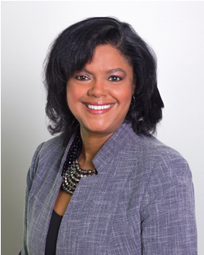

About Our Guests: Dr. Windy Dean-Colomb
Medical Oncologist, Our Lady of Lourdes Regional Medical Center

Dr. Dean-Colomb indicates she can’t remember a time when she didn’t want to be a doctor. She often jokes that she thinks her parents brainwashed her at an early age Nevertheless, life experiences cemented her desire to become a physician and a cancer specialist. Right before she was supposed to start medical school, her 24-year-old brother was diagnosed with colon cancer, with the doctor telling him “not to start reading a long book.” He died eight months later, making it the event that caused Dr. Dean-Colomb to focus on becoming a physician-scientist in oncology.

She initially received her undergraduate training at Prairie View A&M University in Prairie View, Texas where she graduated with honors. She then moved to Champaign-Urbana, Illinois, where she completed the rest of medical training including a combined MD/PhD degree through the University of Illinois’ Medical Scholars program.

Following a short stent working with FEMA after Hurricane Katrina, Dr. Dean-Colomb then moved on to Houston, Texas where she completed her medical oncology training at MD Anderson in 2007. There she distinguished herself as physician-scientist with a focus on the treatment of breast cancer, especially in minority women. She has published several articles in this area and has won numerous awards and grants for her work, including a 2009 American Society of Clinical Oncology Merit Award for her research. Today, her work focuses on cancer disparities and, in particular, triple-negative breast cancer and prostate cancer, both of which have demonstrated extraordinary differences in outcomes both here in the United States and abroad.
Dr. Dean-Colomb has proven a desire to provide compassion care to the underserved, both here and internationally, and has participated in numerous medical missions in many developing African and Caribbean countries. Her driving philosophy is that a doctor’s role is to provide quality care to every person, in an emphatic and compassionate manner. “A diagnosis of cancer is a devastating thing to happen to a person and one of the greatest treatments we can offer our patients is the knowledge that they don’t have to go through this alone,” she says. Dr. Dean-Colomb currently serves patients at Our Lady of Lourdes Regional Medical Center in Lafayette, Louisiana.

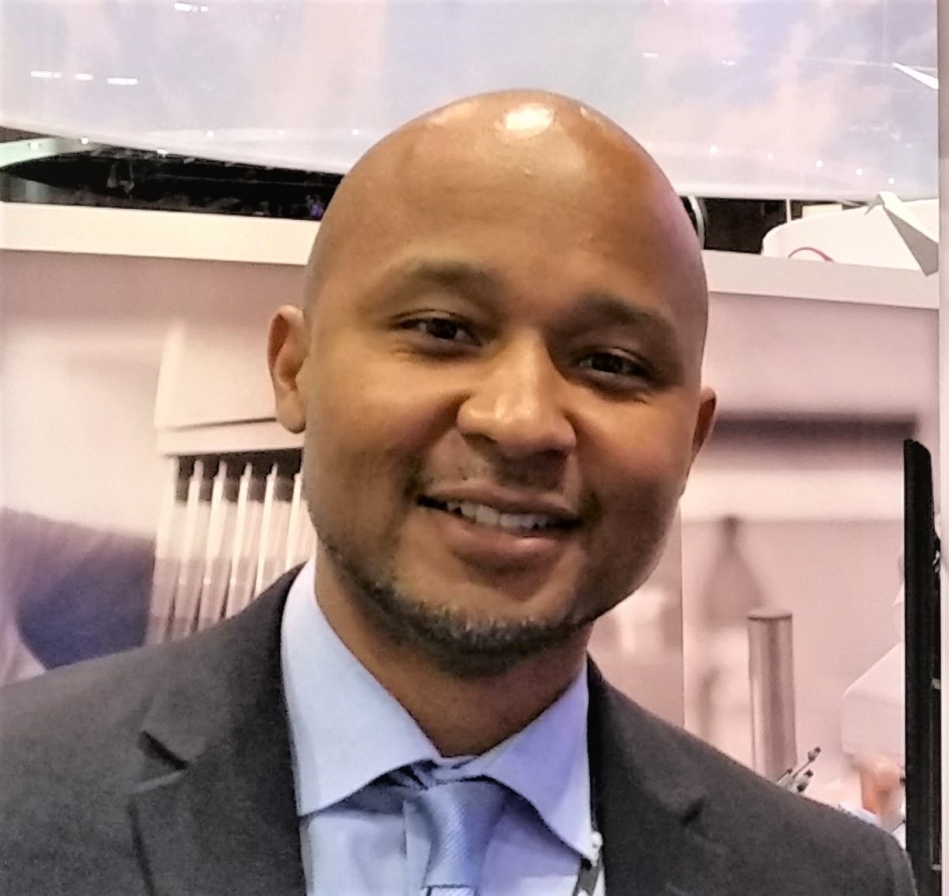
Dr. Clayton Yates
Professor, Department of Biology and Center for Cancer Research
Director of Center for Biomedical Research

Dr. Clayton Yates is an internationally recognized expert in prostate cancer health disparities research, cell biology, molecular biology, and molecular pathology. His specific research interest is in epigenetic alterations that contribute to aggressive cancers in African-American patients.

Dr. Yates currents holds appoints in the Center for Cancer Research, and a joint appointment Materials Science and Engineering at Tuskegee University. He is also Adjunct faculty at Clark Atlanta University Department of Biology and Department of Pathology at University of Alabama at Birmingham and the Research Director for the Transatlantic Prostate Cancer Consortium, which is focused on understanding the tumor biology in native African men in Nigeria and developing novel clinical interventions for this population. Additionally, Dr. Yates acts as the principle investigator (PI) of the Research Centers at Minority Institutions (RCMI), site PI of CTSA (jointly with UAB-hub institution), and co-PI of U54 Cancer Health Disparities with Morehouse School of Medicinal and University of Alabama at Birmingham.

Yates earned his PhD from the University of Pittsburgh School of Medicine Department of Pathology in 2005 as well as certificate of training in Tissue Engineering and Regenerative medicine from the McGowan Institute of Regenerative Medicine. He then went on to complete a postdoctoral fellowship at Emory University School of Medicine Department of Urology. After completing his post-doctoral training in 2007, Dr. Yates accepted a tenure track Assistant Professor position at Tuskegee University in the Department of Biology and Center for Cancer Research. Dr. Yates was promoted to Full Professor in 2014.

Dr. Yates has established several cell-lines based models derived from African-American patients that are used by many labs today to study molecular events the lead prostate cancer development and metastasis. Additionally, Dr. Yates has identified multiple biomarkers for the prediction of aggressive cancers in African-Americans with prostate or breast cancer, and this has led to the development of a novel therapeutics for African-American breast, prostate, and pancreatic patients. He has received numerous research honors and awards, authored over 65 peer-reviewed publications, participated in numerous Department of Defense and NIH study section panels, and received numerous DOD and R level NIH grants in prostate and breast cancer health disparities, totaling over 25 million dollars in extramural funding.

