EPISODE NINE:
Digital Health Tools Are Disrupting Precision Medicine, and Luba Greenwood is On Board

Luba Greenwood, J.D., Strategic Business Development and Corporate Ventures at Google Life Sciences, Verily, | March 11, 2019
Welcome to The Precision Medicine Podcast, where experts come to discuss the problems oncologists, reference labs, and payers face as precision medicine grows, and consider solutions for advancing the quality of patient-centered cancer care.
Jerome Madison: Welcome to the Precision Medicine Podcast. I'm Jerome Madison, Vice President of Provider Relations at Trapelo and one of the hosts of the Precision Medicine Podcast. And today we have Luba Greenwood, someone who's at the forefront of digital health. She works in Strategic Business Development and Corporate Ventures at Google Life Sciences and we're excited to have her share some great news of what she's got going on.
Jerome Madison: Luba, thank you for being a guest on the Precision Medicine Podcast.
Luba Greenwood: Jerome, thank you for having me.
Jerome Madison: If you don't mind, give us a little bit about your background because you're an attorney, but you have a really extensive background in precision medicine and digital health. Tell us about how you developed your expertise in healthcare and in precision medicine.
Luba Greenwood: So I started out actually in science and at that time I was very passionate about translational medical research. And so that really drove me into law because when I looked at very early research and innovation, and really at its core and specifically in therapeutics, diagnostics and med device industries, I saw that the initial value really lied in the patents, and also the subsequent success of many of these innovative companies lied in clinical validity and development. And obviously ultimate approval of these therapies came down to regulatory law. So when I went into law, I practiced law at Wilmer Hale for eight years and I specialize in intellectual property for that reason and regulatory matters, as well. And while I was an attorney, I represented clients, they were big companies, small companies, and they were really across the entire healthcare continuum from pharma companies, biotech, med device and diagnostic to payers and providers, as well as many tech companies as well.
Luba Greenwood: And at that time, while in law, I had the opportunity to gain pretty good insight into what drives innovation and also ultimately what the incentives were at the time. And the trends were, as to the incentives in the healthcare system. So when I went onto the business side, I brought those insights with me and really used that science and legal training to one. I was in venture to identify the best innovative companies. And as you see many times, both in healthcare and the digital health side as well as in therapeutic side and diagnostic side, there's quite a bit of hype out there. So the training really helped me concentrate on those companies that have a very strong team, very strong data, good intellectual property protection and a pathway to regulatory success, as well as physician and patient adoption. Because if you look ultimately precision medicine, it really is a mix of all of those components. And I'd say probably in particular a combination of therapeutic discovery, development, diagnostics and big data.
Jerome Madison: We were really excited to connect with you because you are a leader and an innovator in the Boston area. I mean, you lecture at Boston University School of Law, you are on the board, the co-chair of Mass Bio's Entrepreneurs University and in fact, Massachusetts Biotechnology Council. For those of you who are not in Boston, you guys just were in the news and had a great press release yesterday in the Boston Globe. Tell us a little bit about what that was about.
Luba Greenwood: Sure. Thank you for asking about that.
Luba Greenwood: I'm very excited to be on the board of Mass Bio and really work with an amazing team, both of Mass Bio board members as well as the Mass Bio team. Bob Coughlin, Kendall and others as well as Deloitte who has helped us in the last nine months very diligently to put together this digital health report. What we wanted to do and highlight there is a strategy for Massachusetts to make sure that we can be the leaders at the convergence between digital health and life sciences.
Luba Greenwood: We know that here in Massachusetts, we have all the tools to make this a success and we have been working together just to make sure that we leverage those tools and become a life sciences and digital health leader in Massachusetts.
Jerome Madison: So with the report, what are your plans going forward? What do you guys like to do?
Luba Greenwood: So we have created a multi-year strategy that will enable convergence between life sciences and digital health that would have a number of main pillars. One is Mass Bio will create Mass Bio.DH, which is a program that will support many early-stage digital health companies – really through mentorship. We'll also launch a digital health investor working group and this will bring together leading investors and also some of the main stakeholders here in Massachusetts that are in the space. And lastly, we'll start working with the government in order to advocate for increased data access.
Jerome Madison: We met at the Precision Medicine Coalition when you were on a panel that was titled “Predicting and Preventing” and a lot of the comments that you made there were related to digital health and kind of the direction that you guys are now going with Mass Bio. But you were quick to remind us all that precision medicine is more than just cancer, with heart disease and diabetes. What type of type impact do you believe precision medicine will have on the management of these other autoimmune diseases?
Luba Greenwood: Precision medicine obviously plays a huge role and a very vital role in cancer. However, it really is about much more. And I'm so excited to see many companies embracing the use of precision medicine tools to really tackle some of the costliest diseases that we have currently in the United States. And those really include heart failure, diabetes, COPD. That also includes neurodegenerative diseases, autoimmune diseases such as Crohn's and rheumatoid arthritis. And we know by using those precision medicine tools such as digitally phenotyping, for example, or providing ways to let patients report self-reported outcomes, analyzing those outcomes and data, drawing insights from that data. We can now really build tools to help patients manage their chronic disease. And moreover, which is also extremely exciting, is that we can now make more targeted therapies, right? So it's not simply about disease management, but it's drawing the insights in order to make more targeted therapies and use that data collected from patients in real time.
Luba Greenwood: Other things that we can do with personalization, which is another key as we move into the value-based care is to help patients improve medication adherence. We know with many medications and therapies, medication adherence is still relatively low. So we can use personalization in order to improve that as well. And lastly, I would say, and this is key as the population is aging, is we have an ability now with precision medicine to check drug to drug interactions so that you can stop some of the adverse events. And that's really a key factor in managing care for the elderly. Because elderly often have multiple comorbidities and are on multiple medications.
Jerome Madison: You also said that precision medicine is more than just genomics, which is really cool because this was a conference about cancer care and how we're making innovations in cancer care. And you were the one person on that panel to point out in big fashion that, "Hey, this is not just cancer." And not only is precision medicine not just genomics, which is a large part of what we were talking about. You said it's not just genomics and urged us to look beyond genomics. Can you talk more about what you mean by that?
Luba Greenwood: Genomics, no doubt. And you've seen at the conference there are some really incredible people that are working on genomics, working on cancer treatment and genomics. The use of genomics. And genomics has opened up enormous opportunity in drug development and discovery and really understanding of the disease. However, we also know now that epigenetics plays a big role. We can look at factors beyond genomics such as social determinants of health. We can look and gather self-reported outcomes data, environmental data. We can get continuous data from sensors and really combine data from imaging and blood and nutrition. Your clinical data, molecular data and all of this data is really beyond genomics and, in addition to, and beyond genomics so that we can truly understand the underlying disease and it will enable us to gather -- all of this data will enable us to come up with better and more targeted therapies.
Jerome Madison: Maybe similar to that, Google used artificial intelligence with multiple data points to diagnose diabetic retinopathy. What implication is using artificial intelligence to kind of go beyond just genomic data points to better diagnose and make us better at treating patients?
Luba Greenwood: Yes. So, absolutely you have now an ability to, for example, the way they did that is to scan images, back of the eye fundus images in order to determine for an algorithm. Really it's using deep learning algorithms in order to determine diabetic retinopathy. So again, this is another example of how we could use some diagnostic tools that are not relying on genomics, that are relying on images and recognition algorithms to recognize images in order to drive diagnostics. And that's an incredible tool because as you know, in many countries, especially in India, it is hard to get to an ophthalmologist. So many diabetic patients that get diabetic retinopathy do go blind. So this is really an exciting opportunity to get in front of that diagnosis and make a big difference in patients' lives.
Jerome Madison: I love the way you talk about digital health and the value of digital health because you have said that the value is in helping us do what we do better and more efficiently, not necessarily differently. Is the value of digital health to really kind of transform the way we treat patients or to make us improve outcomes with the current way we treat patients?
Luba Greenwood: So I'm glad that you asked this question. People are often caught up and thinking through basic definitions of digital health and digital health means different things to different people. It really depends on where they come from and their industry, their background, their training. For example, someone from tech looks at digital often as consumer play. Clinicians look at medical workflows, payers look for transparency tools. I come from health care and also having that science and legal background and I come from the world of making therapies to make patients’ lives better. So that's my perspective. What I see today that markets and venture portfolios and incubators are currently really flooded with very fun and enticing digital tools. But most of these are really just tools. They're products and not real businesses. They don't have business models for revenue generation, for example. Many of them will fail to show clinical validation or evidence of improving patient outcomes.
Luba Greenwood: So many also, at times don't address real medical need or how it fits within a medical workflow. So for me the value, the real value of digital health is really in the true precision medicine space, which I see as applying relevant data to improve patients' outcomes. And the way that you can do it, you can do it in multiple ways. So just to give you an example, you can design better drugs for a particular cohort and enroll only those patients that truly benefit from that drug. And also with limited adverse events. In addition, you can with precision medicine tools, you can now have therapeutics that can come with a tool that would enhance that particular patient's adherence to the medication. And that would both include improve the outcomes for the patient and also help those current therapeutic companies really exist and flourish in a value based care system.
Luba Greenwood: So I see that as true personalization. It's really using data to make better drugs for you, better efficacy, less side effects, and better adherence. So that's really therapeutics. Just a brief few examples. A medical device and diagnostics. A medical device, you can use sensors for example, to help patients continuously monitor some other key biomarkers, right? Not just go in once in a while when you see a physician, but continuously monitor your blood pressure, continuously monitor your glucose and other key markers for you for the disease so they can manage their disease in real time. Or for surgery for example, you can implant sensors that can monitor infection that can help you recover post-surgery. So this is where I see where the value in digital health really comes from.
Jerome Madison: They've even mentioned, and you talk about it so eloquently, the way that we're going to bring technology into helping us be more efficient and even practice precision medicine. But my goodness, I mean Goldman Sachs in a press release predicted that the market for such ventures could top $32 billion. Holy cow. That's a lot of promise in digital health, bringing innovation and disruption to that market.
Luba Greenwood: Absolutely. That's very exciting. One thing to note there though is that many of the companies need to get very good data and that's where access to data and good data and valuable data that you can gain meaningful insights from will become more and more important, as we move forward.
Jerome Madison: You talk about disruption, right? And in fact we interviewed Brad Power, who's a journalist and written numerous articles in the Harvard Business Review and his expertise is process re-engineering. And his question that he asked is where's the disruption going to come from? But you, in some of your lectures, you say the most disruptive area of digital health ecosystem, you call disruptive diagnostic tools. What exactly does that include and why are they the most exciting to you?
Luba Greenwood: I would say disruptive diagnostic and therapeutic tools. So I would say I divided digital health into three simple buckets. I like to view the world that's part of legal training in three simple ways. One of the buckets, I would say the third bucket, is looking into digital health from a healthcare perspective, which usually traditionally includes five main pillars and includes reimbursement, regulation, meeting unmet medical need and patient needs as well as physician adoption, and of course intellectual property protection. So these are the main ingredients in the lens that I look through when I look through at innovative companies and also try to understand whether or not that innovative company will really be disruptive or effective and whether or not it's going to make a real impact in patient lives.
Luba Greenwood: So the area that I think is most valuable, is really is that area where your product, your business is going to take on all those elements of the life sciences industry and go through those IP regulatory physician adoption reimbursement hurdles. However, that area is also the one that offers the biggest opportunity in healthcare and specifically in a world where we're moving today into value-based system and where we want to improve outcomes at a lower cost. So some examples of what I really mean by that and what fits into that. I'm glad that you brought up earlier the digital retinopathy tool. So it's really those digital tools for diagnosis, for analysis, for monitoring and screening.
Luba Greenwood: So one example is a deep learning to detect diabetic retinopathy. Another example is for example, using machine learning to detect metastasis of breast cancer. You have digital therapeutic companies like [Akili 00:15:31] and [Pear 00:15:32]. Disease management tools for example, like [On Duo 00:00:15:35] or MySugar. You also have tools that would fall into it and companies that help with collection of real world evidence and helping with patient enrollment and virtualization of clinical trials.
Luba Greenwood: Because today what you see is consolidation in the industry between ... You see consolidation with PBMs, with payers, with providers, and they're all built in order to integrate care at the end of the day. The goal is to keep patients outside the hospital. So if you have tools that empower and enable that patient and caregivers to keep that patient outside of the hospital, those are the tools that are going to really disrupt the business. And so for example, if you're making a diagnostic tool, think about the point of care or at home rather than the hospital or in central lab.
Luba Greenwood: And then on the therapeutic side is again, making those therapies that are more precise and data driven on the taking care of patients, making knowledge management tools that customize care for each individual patient. So when you, as a patient, you go in, your physician has given you the recommendation that is relevant for you and is treating you and not just somebody general that has a particular disease. But all of those tools that I just mentioned, it's not easy, right? Because in order for them to be successful and disruptive, they all have required clinical validation. They all require significant data to make it meaningful. They all require intellectual property protection and ultimately regulatory approvals.
Luba Greenwood: But I can tell you if pharmaceutical companies and biotech companies and digital health companies, if they invest and develop those tools, they will not only do well financially, but they really will make a meaningful impact on the improving patients' lives.
Jerome Madison: Yeah. So you've been in the venture capital space and matter of fact you teach or you lecture and you co-chair the Mass Bio's entrepreneurs university. I've always said the precision medicine industry is an entrepreneurial experience and I've worked in this industry that we know now as precision medicine for 16 years. But something that I've heard you say is that many of the executives who are coming into the precision medicine industry are not from health care. You know, as you talk about Google ventures and different companies getting into this space and investing heavy and seeing promise. Is this a good or a bad thing that these different leaders don't have healthcare experience?
Luba Greenwood: I think it's a good thing. I think I always have the more the merrier approach. I think it's wonderful because the healthcare side can learn a lot from the tech side than the clinicians. Just like the tech side can learn a lot from healthcare side. I think what's important though is to make sure that, and this is one of the things that was key for us to ensure that Massachusetts offers is the right type of mentorship for many of those companies. Because a lot of the companies that you see today that are funded very well are started by two types of people.
Luba Greenwood: You have somebody that comes from the software engineering side, from tech that sees a small problem that they would like to fix. And then you also have brilliant clinicians, young clinicians that are coming out of medical school and residency and find the practice of medicine frustrating and they identify many gaps that could be easily filled with digital health tools. Now those are wonderful people to start those companies and are the right people to start the companies. But they do need the mentorship from healthcare leaders. They need the mentorship on the intellectual property side and the reimbursement side, on understanding and making their company from just a product to actually getting to the patients and to get into patients, you have to have clinical validation, you have to have reimbursement, you have to have a safety, of course and right data.
Jerome Madison: Yeah. You have done so much in the Massachusetts and the Boston area with respect to entrepreneurship. Specifically in this area. But I thought it was also very interesting that you give back quite a bit, too. Not only with your chair of different philanthropic activities. You have been a part of the Science Club for Girls Catalyst. Matter of fact, you won an award, the Science Club for Girls Catalyst Award for your commitment to advancing women in science and technology and you are also on the board of the Longwood Symphony Orchestra. Where does your desire to give back and to make an impact in the community come from?
Luba Greenwood: First of all, that's really for me and my career has always been driven to give back. I have to say, having had the opportunity to come to the United States and be educated here and everything that the US has given me, I've always wanted to give back. I see a great need for, in healthcare space and a lot of talent in the healthcare space. So I'd like to give back as much as I can of my time and energy really to ensure that we have the best and the brightest people coming up with the greatest therapies for patients, in order to make lives of patients better and also to make sure that we have the right environment for entrepreneurs. For young people that are entering the space, for women and minorities and to make sure that there is diversity because that's really key, as well.
Jerome Madison: What are of the nonprofits that you're aware of in the Boston area or that you work with that advocate mentorship programs for the development of young people in STEM, life sciences and technology?
Luba Greenwood: There are a number of them, but they're kind of all over the place, which is the reason why when we're putting together the Mass Bio DH, we are going to create Mass Connect. Mass Connect, it is a mentorship program for people in biotech. So if you are a postdoc at one of the local universities or if you just received a PhD or even an undergrad in science, you can start a company. If you're thinking about starting a company, you can enroll in what's called Mass Connect, which is part of Mass Bio and it mentors you to figure out, well how do you put together a team? How do you identify what you want to go after? How do you in license that product?
Luba Greenwood: Many of them say, "Hey, I worked as a postdoc with my professor. That's really my invention. I would love to in license it." Right? And so you have some people that are actually lawyers that help you in license the product and then you pitch to somebody that helps you with the pitching and then ultimately with your exit. So that's what Mass Connect has done.
Luba Greenwood: You also have MIT 100K. I started working with MIT when it was 5K, so you can imagine how long that was. It's now 100K. So that's another great organization. Also, Mass Challenge is a wonderful organization as well. They're actually not just Massachusetts. I always thought it was Massachusetts, but actually Mass does not stand for Massachusetts. They do amazing work, as well. And they're not just in life sciences, they're also in digital health. They're also across various different industries. They're in clean tech, energy and in other industries.
Luba Greenwood: So there are a number, but one of the things that we wanted to do at Mass Bio is because digital health is a very tricky place, right? It's one where IP is not so straightforward. You can't usually say, "Hey, I'm a postdoc. I worked here, so now I would like to in license this." It's much more tricky than that. You also have to get data. So how do you get data? How do you have access to the data? Where do you get the money to get the data? And also all that clinical validation, all those things that I was mentioning, that's also difficult, right? So we felt like we need a lot more help on the mentoring side and bring various mentors from very different types of backgrounds to really get those digital health companies off the ground.
Luba Greenwood: So as part of Mass Bio DH, they're going to start a new program that's like Mass Connect at Mass Bio. The same thing with Mass Challenge, they have this thing called Pulse and Pulse is specifically for digital health. And now you have Harvard i-Lab and you have a number of other kind of smaller groups that are doing this, but I would say the biggest ones are probably Mass Challenge and Mass Bio.
Jerome Madison: We want to thank Luba Greenwood of Google Ventures, and of course all of our listeners for joining us today. We hope you'll tune in for the next episode of the Precision Medicine Podcast. And don't forget, you can download full transcripts of today's episode at precisionmedicinepodcast.com.
Jerome Madison: Also follow us on Twitter, @PMPbyTrapelo. That's P-M-P B-Y T-R-A-P-E-L-O. Also connect with us on LinkedIn. If you enjoyed this episode, you probably know someone else who would too, so please tell them. They'll thank you. And so will we.

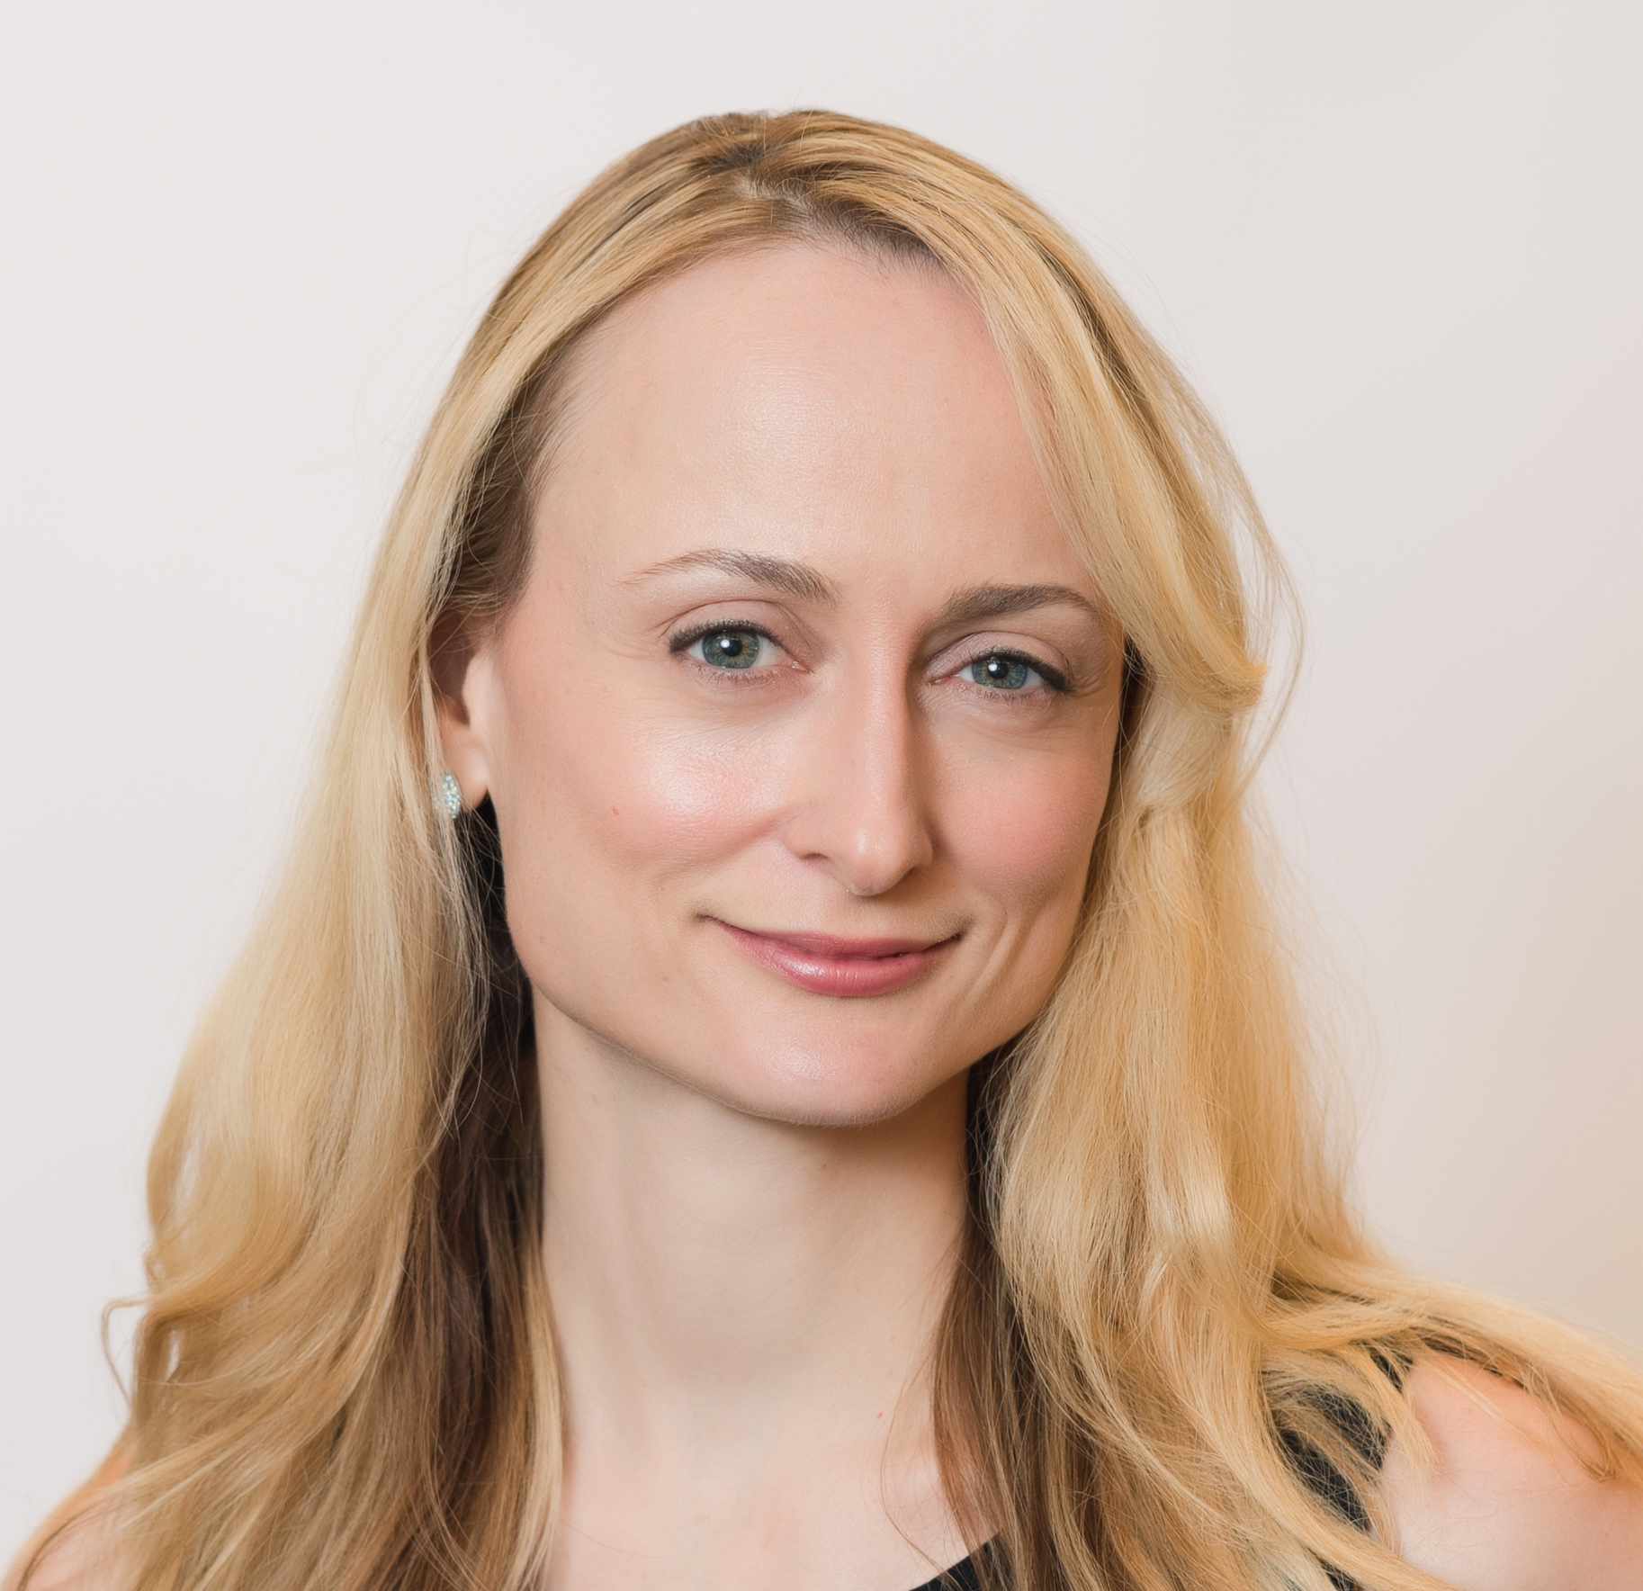

About Our Guest

Luba Greenwood, J.D., Strategic Business Development and Corporate
Ventures at Google Life Sciences, Verily, an Alphabet company

​
At Google, Luba leverages her pharmaceutical, biotechnology, and digital health industry experience and expertise in building and investing in innovative technology companies and providing strategic counsel to global corporations. Previously, Luba served as Vice President of Global Business Development and Mergers & Acquisitions at Roche, where she also established and led the East Coast Innovation Hub for the Diagnostics Division.

Luba is on the Board of MassBio and Brooklyn ImmunoTherapeutics, and
serves as Advisor to Dana-Farber Cancer Institute, as part of its Business Development
Council. Luba is a Thought Leader for the New England Journal of Medicine (NEJM)
Catalyst, Founder for the Pharma Digital Health Roundtable, and a Lecturer at Boston
University Law School and School of Management where she has taught courses in life
sciences, business law, innovation, and entrepreneurship since 2014.
Luba’s career has spanned leadership roles in venture investing, business
development, Mergers & Acquisitions, law, and operations, previously serving as
Venture Partner at Colt Ventures, leading BD and Strategy for Axcella Health, a
Flagship Ventures company, and serving as Senior Mergers & Acquisitions Counsel at
Pfizer Inc. Luba began her career practicing law at a leading national law firm, Wilmer
Cutler Pickering Hale and Dorr, where she represented clients in securities, IP,
regulatory, corporate, and litigation matters.
Luba is a recipient of several awards and honors for her work in the community,
including the Science Club for Girls Catalyst Award for her commitment to advocating
for women in science and technology. Luba served as non-profit board member of
Longwood Symphony Orchestra, executive coach for MassNextGen, co-chair of
MassBio’s Entrepreneur’s University, and mentor and judge for MassCONNECT, MIT
100K Entrepreneurship Competition, and MassChallenge.

Related Links:

Twitter: @Luba_Greenwood
LinkedIn: Luba Greenwood

Boston Globe Article: "Study praises tech, but has suggestions for how Massachusetts can become a digital health hub

