SEASON TWO: Episode 40
Part 1, Dr. Gabriel Bien-Willner: Reshaping Reimbursement Policies for Genetic and Genomic Testing

October 29, 2020

Karan Cushman: Welcome to season two of the Precision Medicine Podcast sponsored by Trapelo. This is the podcast where experts come to discuss the problems oncologists, reference labs, and payers face as precision medicine grows and consider solutions for advancing the quality of patient-centered cancer care. Be sure to subscribe at precisionmedicinepodcast.com to get the latest episodes delivered straight to your inbox.
Jerome Madison: Welcome to another episode of The Precision Medicine Podcast. I'm Jerome Madison. And today we have Dr. Gabriel Bien-Willner, Chief Medical Officer at Palmetto GBA and Director of the MolDX program. Dr. Willner, thank you for being a guest on the podcast.
Gabriel Bien-Willner: Thank you for having me.
Jerome Madison: So, I've heard you speak at different conferences, and you have a very unique perspective on precision medicine from a payer perspective, but tell us a little bit about your background and your career path to where you are now with the MolDX program.
Gabriel Bien-Willner: Sure. Yeah. I have a long history of how I got here. So, you're going to have to cut me off if it starts to stray for too long. So, I'm an MD-PhD from the medical scientist training program. I was always very interested in genetics and genomics and wanting to bring genetics and genomics into the clinical space. That's if there's one sort of running theme that will make sense as you listen to all the different things I've done, that's sort of a core guiding principle for me or always has been. Other things have constantly changed, but that's always more or less remained the same. And while I was in residency, this new technology was just starting to emerge called Next Generation Sequencing Technology. And looking back towards the end of my PhD, I had all sorts of questions that I could not answer.
Gabriel Bien-Willner: I had a lot of studies that I never finished or published because the technology didn't exist to allow me to look at broad sectors of the genome at concurrent. We had two previous to next generation sequencing. We had to know what we were looking for, and then we could only explore that thing that we already knew was there more or less. So, I had a lot of experience even before my PhD working to some degree in genomics. Actually before my MD-PhD, I was at the National Institutes of Health, doing scientific training there and working in a lab, doing genomics at the same time that the NIH was publishing the first draft to the human genome. So, I got to be exposed to a lot of that. Although I wasn't directly working on that. I went to Baylor College of Medicine and did my PhD in human molecular genetics.
Gabriel Bien-Willner: And I worked in a constitutional genetics laboratory, looking at basically rare pediatric diseases. The lab I was in focused on genomic rearrangements. And towards the end of my PhD, I kind of did my own unique path there and went in and strayed heavily from the core focus of the lab. My PI wasn't happy with that, but I was just going to do whatever the science led me to do. And I decided that WashU was actually a hotbed for some of the research around Next Generation Sequencing Technology, and I wanted to work in that field. I thought it could answer a lot of the questions I had from my previous work. And I could apply that same technology to those previous questions. Although now I had a whole new set of questions around cancer, and I wanted to be able to use this technology to answer those kinds of questions.
Gabriel Bien-Willner: And WashU was actually kind of at the forefront of some of this development, there was a gentleman who had recently started a laboratory at WashU that helped develop some of this technology. His name is Rob Mitra, and I started doing research during my residency in his lab. And it was interesting. So my PhD is in classical genetics, even though I did started to incorporate some computational genomics towards the end of the PhD. I didn't have any real traditional bioinformatics training or I didn't know computer coding, but I really quickly realized that, that was an essential component of this new technology. That you couldn't just look at a sequencing tracing to come up with what the genetic code was or the genetic sequence was. You're now getting hundreds of millions of reads of DNA, and you need to have a computational approach to look at it.
Gabriel Bien-Willner: I know this has already been prolonged significantly, but I went to WashU for residency, fellowship post-doc and faculty position. And I got to really get my hands very dirty in a very new technology, which is Next Generation Sequencing Technology. At the time when very few clinicians were anywhere near this stuff. And I was going to stay at WashU forever. And that was the goal. I bought a house in St. Louis, and I spent five years gutting it and remodeling it. And I just finished the kitchen when I realized it was time to go, and I never really got to enjoy it. Someone else got to enjoy the fruits of my labor in that house, but I had a lot of industry knocking at my door realizing that this technology and its application for cancer was going to explode.
Gabriel Bien-Willner: And I was one of the few at the time, real knowledgeable people in how to create clinical laboratories and validate tests in this setting. Certainly not the only one, but I had a lot of exposure and experience in this field. And then this opportunity came up... Oh, finally, we're going to get to how I got the job I have now. I was very happy to do that. And then this opportunity came up to be the director of the MolDX program. At the time, even though those of us in the field were very gung ho about the future of medicine and precision medicine and molecular diagnostics, there were a lot of big obstacles in the way. From the provider side, we're sort of obscure. We knew we had some variety of issues and a big one was the payers.
Gabriel Bien-Willner: Why don't the payers understand these tests? Why don't the payers pay for these services? And I had the opportunity to interview for this position, understanding that the MolDX program is very important for the payers and understanding these tests and making policies around these tests. And I accepted the invitation because I really wanted to come away from... I really had no intention of taking the job. I really wanted to understand who these people were, and I wanted to understand how they made decisions. So in the past, they've made some very controversial decisions on that. I'll just say that many of us didn't... That those at the forefront of this technology didn't really agree with. I went to South Carolina, interviewed for the position and talked about my experience and why I was qualified for the position, and they told me they were looking for someone who was a subject matter expert, or even a key opinion leader in the field.
Gabriel Bien-Willner: And at the end, they asked if I had any questions for them. And I did, I had a lot of questions for them. And I wanted to know why they made certain decisions and what they were thinking and why they weren't doing better at this or that. And I really just wanted to give them a piece of my mind. And as a result, I think it accidentally triggered something in them and realizing that they thought that I could do a good job running this program. So they offered me the position. And the more I thought about it, the more I realized that running labs for companies or helping individual patients looking at their... Helping oncologists understand the reports better, running precision medicine programs, which I'd done all of. Being able to help the payers understand these tests, especially Medicare and making policy would allow me to not help one patient or one hospital system. But really all of the Medicare beneficiaries by being someone who's really knowledgeable in the space making very important decisions.
Gabriel Bien-Willner: Before taking this job, I'd often discuss with other leaders in this space, what we could do to prove that there was value to these tests and who we would need to put together in a strongly worded letter to get through to the people who make decisions. And now I realized that I could just be that person that makes decisions or be one of the people who makes decisions. And I realized just how important this role was. And really that's why I took this position. I realized that I could do a lot more good. And again, the goal in me taking this position wasn't to force medicine to accept something it wasn't ready for. It is really to bring real expertise to the evaluation of evidence and understand if these tests or which of these tests have met the criteria for what is reasonable and necessary that you need to demonstrate for coverage. So, that's really what I bring to the table and I'm very happy in this role.
Jerome Madison: Many of our listeners and folks in the industry who've been a part of what we consider precision medicine have heard of MolDX. They've heard of Palmetto GBA, but can you explain what the MolDX program is and what is the relationship with Palmetto GBA?
Gabriel Bien-Willner: Yeah. No, thank you, Jerome, for that question. So I think the payers or providers in general—myself included before it was on this side—have not had a very good understanding of how Medicare works. There's not a central office where you perform a service and you send an invoice to Washington DC, and then they pay that bill. That the Medicare program is not run centrally. It's really run locally, and it's not really even run or operationalized by the government. It's run by Medicare administrative contractors or MACs. These are private entities that bid for administering the program to the central government. And when they win those bids, they administer the program for certain regions, countries broken up into jurisdictions. And one of these MACs or Medicare administrative contractors is Palmetto GBA. Palmetto GBA currently has two contracts, the JJ and JM contracts, which let's just say covers most of the Southeast.
Gabriel Bien-Willner: So, they are the company that I'm an employee of. They pay my checks, and I'm a chief medical officer with this company. Then there is the MolDX program. So part of one of these contracts, which is the JM contract, this specialty program was created and is supported by Medicare. And this is the MolDX program. The point of the MolDX program is specifically to understand the molecular diagnostic space, to write policies for this space, to evaluate tests, to create payer controls, to be able to handle these tests. And we can get into the details of why molecular diagnostics is so different than all other medical specialties, that it requires a specialty program. But that's the point of the MolDX program. And it actually is a joint program with three other MACs. And that is the Noridian MAC, which is basically the West Coast and Northwest.
Gabriel Bien-Willner: The CGS, which is part of around the Midwest and WPS, which is also in the Midwest. So, this program, we write policies, we create the payer controls and then our policies and controls then go out to these other MACs and they institute these policies and controls. So, we write policies that affect 28 states and controls that affect those same states. And I am the director of this program.
Jerome Madison: You mentioned that Palmetto was looking for a subject matter expert, and I'm sure you've heard this. And being in the industry for a while, I hear from providers who lament dealing with their insurance companies and that they don't have that expertise, and they have to explain why they need access to a drug that there's a clear indication for. In fact, on our podcast, Robin Toft talks about a talent crisis in this space where there's just not enough experience, skill, and knowledge for leaders, for companies that are leading companies into this precision medicine future, if you will. But other than just kind of the talent and the know-how, what have been some of the challenges from the payer perspective that you've seen and that payers have had to navigate as this precision medicine space, the explosion of diagnostic test has grown over the last few years.
Gabriel Bien-Willner: Sure. So, the MolDX program was really created to try to navigate the challenges. So, let me go through some of what that is. That the talent aspect of this is very palpable. So, the way Medicare works is that the determinations, the policies are written by CMDs or contracting medical directors. So, I told you I had two titles basically within Palmetto GBA, but I have a third title in this role. I am the chief medical officer for Palmetto and the MolDX director, but I'm also a contract medical director for CMS, which means the Centers for Medicare Medicaid services. What this means is that I'm authorized by CMS to speak on their behalf and make decisions for them. The way that the Medicare program works is the CMDs are hired by the MACs to make these policies, and they have to be physicians.
Gabriel Bien-Willner: And there's a level of expertise and experiences required to have these roles, but there tends to just be a handful of CMDs for each MAC to handle all of medicine. So, a typical CMD would have to make decisions not only about laboratory medicine, but cardiology and oncology and nephrology, and write policies for all of these completely unrelated medical fields. So, you can imagine that you could argue that there's not a core expertise within the MAC for really any of the policies that are generated. So the MACs have ways of getting that expertise so they can put together what's called a CAC or a Contractor Advisor Committee. By the way, let me stop and say that-
Jerome Madison: Alphabet soup here.
Gabriel Bien-Willner: The acronyms are crazy in this landscape. And when I give talks, I usually have a little acronym key. So you follow along. And I remember when I was first on the job, the first day that I met Paul Meadow, I'm standing around with four or five other CMDs, and we're having a discussion. And I remember the senior medical director making a statement to all of us, and it was a joke. And it was a sentence that maybe had two words in it that weren't acronyms and everybody was laughing. And I had no idea what anybody was talking about. So, two years later, I think I'm fairly caught up with it, but yeah, it's a steep learning curve on the acronyms.
Gabriel Bien-Willner: So, anyway, the point of that was to say, "Yes, the talent gap is huge." And if you're writing policy and you don't really understand what you're writing policy about, which is a lot of the time, you have to really rely on people that you know that may be are experts in that field. In the past, before the beginning of 2019 and January, 2019, Medicare... We have to follow the law. We have to follow regulations. We have to follow directions from CMS on how to administer the program. And we had some changes in that direction in January, 2019. We have this thing called a PIM or the Program Integrity Manual. And it was updated in January to explain how we write policy.
Gabriel Bien-Willner: And we have to write policy now based on evidentiary review, which if you think about it should have always been the case, but it really wasn't. The medical directors could make policies for whatever reasons they wanted. And that was that. And now all of a sudden they have to make it based on an evidentiary review of the published evidence, which is something that MolDX was already doing. But now imagine you're a medical director for one of these other MACs and you're asked to write a policy on Next Generation Sequencing Technology based on a review of the evidence, and you're a nephrologist or a pediatrician. How are you going to approach that?
Gabriel Bien-Willner: So, you have to really rely on other experts. And often what happens is they rely on the opinions of let's say like guidelines to establish what is the criteria for reasonable unnecessary? So, if the NCCN decides that this is a service that should be performed then great, then that's what your policy is going to reflect that. And anything shy of that will be very difficult. So, that talent gap is palpable, but that's only one of many issues with payers.

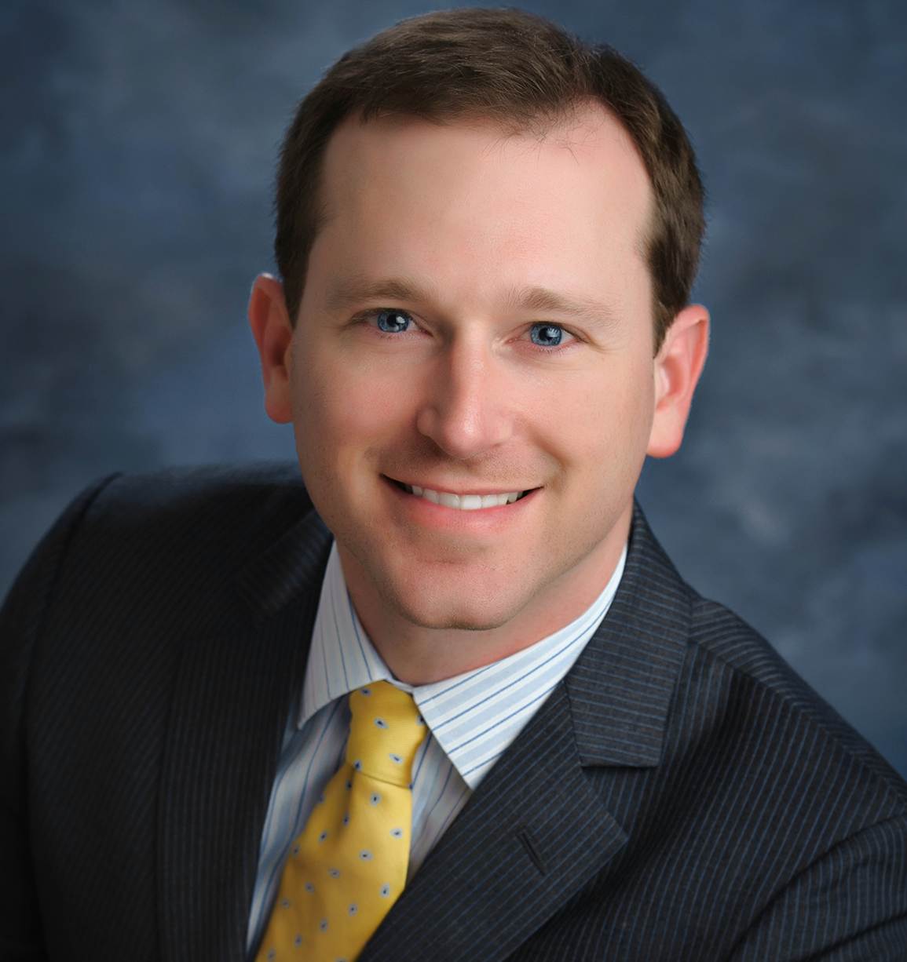

About Our Guest
Gabriel A. Bien-Willner MD, PhD, FCAP

Medical Director, MolDX and Chief Medical Officer, Palmetto GBA
​
Dr. Bien-Willner is the Medical Director of the MolDX program at Palmetto GBA, a Medicare Administrative Contractor (MAC). MolDX seeks to understand the molecular testing landscape to implement payer controls, coverage, and to set policy for affiliated MACs, which currently cover 28 states. He is a leader in the Precision Medicine space and practices as a Board-certified Anatomic Pathologist and Molecular Genetic Pathologist.
Throughout his career, Dr. Bien-Willner has been active in research, development, and advancement of molecular diagnostic services, specifically next-generation sequencing. He has worked closely with clinicians to develop clear clinical diagnostic and treatment pathways for directing Precision Medicine programs at community cancer centers. Dr. Bien-Willner received his M.D. and Ph.D. degrees from Baylor College of Medicine with a Ph.D. in Human Molecular Genetics. He completed his residency and fellowship at Washington University in St. Louis before attaining a faculty appointment there. He held several leadership roles in laboratory and biotech companies before joining Palmetto GBA.

