EPISODE FIVE:
This is Cancer
Laura Holmes Haddad, Author, Cancer Survivor, and Precision Medicine Patient Advocate
January 18, 2019
Welcome to The Precision Medicine Podcast, where experts come to discuss the problems oncologists, reference labs, and payers face as precision medicine grows, and consider solutions for advancing the quality of patient-centered cancer care.
Jerome Madison: Welcome to The Precision Medicine Podcast. I'm Jerome Madison, Vice President of Provider Relations and one of the hosts. Today, I have with me author, speaker, and breast cancer thriver Laura Holmes Haddad, who wrote the book This is Cancer: Everything You Need to Know, from the Waiting Room to the Bedroom. Now that's a provocative title. Laura, thank you for coming on the show and sharing your work with us.
Laura Holmes H.: It's such a pleasure to be here, Jerome. Thank you.
Jerome Madison: Absolutely. We've been talking about this, and you connected with our producer, Karan, who brought the book to us. You mentioned that it is What to Expect When You're Expecting book for the diagnosis you don't want to be stuck with, which is cancer. What inspired you to write the book, and how has it been received?
Laura Holmes H.: Well, the book came about really because, during my journey with stage four breast cancer, I realized how much I didn't know and how much my family didn't know. I thought we couldn't possibly be the only ones who didn't know details, everything from what is chemotherapy really like to what's it like for a young adult cancer patient who also has kids, who also is working? How does cancer affect your marriage, your partnership? All these little details that I couldn't find answers to in the pamphlets in my doctors', my oncology offices. I really set out to answer those questions and really also help patients—create something for patients that they could pick up and say, "Oh, me too. I've felt that way too," and feel some sort of comfort.
Laura Holmes H.: I have to say the feedback has been incredible. Surprisingly, to me, it's caregivers who I hear the most from who really say, "Thank you for talking about things from a patient's perspective, that I had no idea what my loved one or my friend was going through," and it helps them be a better caregiver, friend, support to the patient.
Jerome Madison: I could imagine. You approach it with such a level of candor. If you don't mind, can you tell us about that portion of your journey of receiving your diagnosis and getting to the point where your initial doctors felt that there was nothing else to be done?
Laura Holmes H.: Yes. It took me completely by surprise, as I am sure you hear from every cancer patient, but I had been a very healthy regular 30-something. I had turned 37 when I had this pain that wouldn't go away on my left side of my chest. I had two young children. My son was just about a year old, and my daughter was four, and so I thought I was a tired, busy mom. When I finally went to my GP, she thought, "Well, it's probably a mastitis," and gave me antibiotics and told me to see a breast surgeon "just to be sure." A month later, I finally went in. I got a mammogram, an ultrasound, and a biopsy, and within a few days I found out that I had advanced inflammatory breast cancer. The pain that I had been feeling was an 11-centimeter tumor in my left breast.
Laura Holmes H.: I obviously was stunned and frightened and didn't expect breast cancer, obviously, at such a young age. My family and I said, "Okay. We're going to beat this." We went and got a first, a second, and a third opinion and started chemotherapy. What I thought would be rounds of chemo and maybe some radiation turned into a many-year journey and eventually led me to a clinical trial, which saved my life.
Jerome Madison: Wow. In your book, you mention that it's okay not to like your doctor. We were talking before that I think that's very important because, many times, patients perceive their doctor as their sole lifeline and what that individual says is gospel when, in fact, physicians are as diverse as people with different opinions and levels of experience and, certainly, personalities that work well with some and not well with others. What would you say to other patients to encourage them who feel they want to explore other options but are apprehensive about seeking a second opinion?
Laura Holmes H.: I think that is the biggest takeaway, and the most unexpected takeaway, from my entire experience is the self-advocacy and the prioritization of you, the patient. Understanding that your time and your needs are just as important as your provider's, as your physician's, and you are allowed to not like your doctor. I am someone who thought, "I will show up. Just tell me what to do. I'll do anything you say. I'll take any drug you give me," not thinking that everything else about the physician and the physician's office would matter, especially in something as horrifying and scary as cancer. That is something I hear all the time is someone saying, "I don't want them to be mad at me. I don't want them to think that I don't like them." Number one thing I say is, "It's you. It's your cancer. Do what feels right for you."
Jerome Madison: Yeah. In addition to that, you had to do quite a bit of work or find, really, the courage to do the additional work to find additional care. What was that process like, and how did it turn out?
Laura Holmes H.: Without my family, who fought for me like mama grizzlies, insert any metaphor there, I would not be here. I could not have possibly attempted to research, to contact the medical centers to push and advocate for myself without this team around me. That's what I feel so passionate about now is making sure that people realize that, if you don't have that team, there are other people in the oncology world who will help you because, most often, it's going to take more than you. It's going to take people around you to ... even if it's just helping you navigate your health insurance or help you navigate the scientific terms or understand what your treatment will involve. You need to understand, and you need to ask for help and, often, rely on other people to help you.
Jerome Madison: When you put in that work, what provider did you find, and how did they treat you differently from the initial physician?
Laura Holmes H.: When I found the oncologist who became my oncologist and remains my oncologist, I found a mix of someone who knew the science, who knew the cutting-edge science, which was something that I needed in terms of treatment options, as well as someone who would support me, and not in a hold-my-hand kind of way. That's what I realized is you can't get everything from your oncologist. They're not there to hold your hand, but someone who understood my needs and understood how far I was willing to go. That's ultimately what saved my life.
Jerome Madison: What did they find when they started to approach your tumor differently from a more precision medicine perspective?
Laura Holmes H.: What they found was there were some options. At that point, this was late 2012, early 2013, and while there weren't many standards of care, my oncologist was aware of certain clinical trials. Just his understanding of clinical trial options and how to obtain and apply for a clinical trial on my behalf was, what I found out later, is rare in and of itself.
Jerome Madison: How difficult was it to get into the clinical trial, and what did you kind of find out about that whole process of what it takes to be an approved candidate?
Laura Holmes H.: The education on my behalf about clinical trials was another very unexpected turn. I should say I was an English major. I was not a great science person, so when I heard the words clinical trial, I immediately said, "No. I don't want to be a guinea pig." Every bit of me said, "No, no, no." Then when I found out that, actually, how many people you will help beyond yourself, that in a clinical trial they are trying drugs that could ultimately save your life, I obviously changed my opinion rather quickly.
Laura Holmes H.: In addition, I didn't realize that it is your oncologist who has to apply on your behalf, that you can attempt to research the trials by yourself. However, that is, I would think, a very time-consuming endeavor. You not only have to know everything about your medical background in terms of your chart, but there are just so many elements to make you a candidate. Then, in addition, I didn't know that there are time limits and time constraints. I didn't know that trials are open and closed. I didn't know that trials can happen all over the country. It's these details that are really crucial to understand before you sign on the dotted line, but on that note too, I also didn't realize that you can, at any time, leave a trial, that you are not signing away any rights, that you are not giving up anything by joining a trial.
Jerome Madison: What you shared with us, and I'm not sure if you get into that with the book, but the most intriguing thing to me about your case is you were treated with a PARP inhibitor, which is not indicated for your disease. There is this change of philosophy and belief, especially with oncology, that we're moving from treating the disease that is the tissue of origin to treating the patient's biology, treating that patient based on what their tumor is expressing. That's essentially what happened with you in the clinical trial. Tell us a little bit about that.
Laura Holmes H.: Yes, that is exactly right, and how the term precision medicine and targeted therapy, in addition, is the approach of looking at your tumor profile as well as now recognizing that cancers might not be ... are not separate. That lung cancer does not necessarily have a very different treatment from breast, that lung and breast cancers are actually very similar in some regards. That was a lesson that I had to learn.
Laura Holmes H.: In addition, what I did not know, in terms of understanding my genetic profile, was that that would ultimately create more treatment options, that now scientists are really understanding that certain cells in individual tumors might react to certain drugs, and that this is exactly why the clinical trials are happening and why this ultimately could be such an exciting avenue of treatment options for cancer patients.
Jerome Madison: Yeah. The aftermath of that has been the drug that you were treated with ultimately was not approved for your diagnosis, but you were one of the super-responders in the trial and, as a result ... I'm not sure as a result of that, in particular, but since that time, this drug is now ... there's 96 clinical trials using this targeted therapy, this PARP inhibitor, for different malignancies. How incredible is that to know that you were kind of part of the success and of expanding how people think about targeted therapy and, in particular, this drug?
Laura Holmes H.: Well, you can't see the smile on my face, but it is just so gratifying to know that it not only helped me, but it will, hopefully, help so many other patients. After you go through it as a patient, I don't think you can not feel this inclination to help other patients or to help other people who, hopefully, will not become cancer patients.
Jerome Madison: Not only did you write the book, but you have decided to become a public advocate for other cancer patients. Tell us a little about some of the activities that you do on an annual basis to advocate for cancer patients and precision medicine.
Laura Holmes H.: Yes. This was another wonderful life turn that I really felt compelled to get involved in—advocacy work and telling my story in a broader stage and to reach more audiences. What I've learned is that, given patient privacy laws, HIPAA laws, and just cultural barriers and other barriers, that cancer stories don't always get told, that a patient's perspective isn't always shared. I think it's so crucial to understand that, not only hearing the success stories, but also hearing how it is for patients along the way, that if someone, let's say a researcher, says, "Oh, I have this great drug, and all we need to do is get it in the patients’ bodies," well, in between, you have the patient who can't access the trial, who may not be able to literally get to a trial, who may have small children, who cannot relocate to the trial. Those are just a few things that come up that ... financial, health insurance.
Laura Holmes H.: I mean there are just so many barriers to getting cancer care that that is what I speak about most passionately, and also to show patients, look, I came through this, and I'm on the other side of it. I am living with long-term side effects, but I am here, and I can, hopefully, make some change in not only speaking about the patient experience but, hopefully, moving the needle in terms of research dollars, in terms of ... again, in terms of patient care and, hopefully, provider education and just so many other things that are a part of providing excellent and modern cancer care for patients.
Laura Holmes H.: I've spoken to a wide variety of audiences, everything from American Cancer Society's ACS CAN, which is their legislative effort for research dollars, to making strides against breast cancer. I was the patient voice for then Vice President Biden's precision medicine Moonshot roundtable when I spoke about my experience in the clinical trial. I've also spoken at my local congressman, at his town hall, about proposed changes to the ACA and speaking out about the financial toxicity of cancer care and the implications of losing the preexisting condition status in health insurance, so a really wide variety and, again, really trying to just give my honest perspective and the realities of being a cancer patient in this day and age.
Jerome Madison: Amazing. For those who are out there listening, and you want to get in touch with Laura, Laura, if you could give them your website or your social media handles. How can they get the book, and if they're interested in having you come speak, how can they get in touch?
Laura Holmes H.: Wonderful. Well, my website is lauraholmeshaddad.com. The book, This is Cancer: Everything You Need to Know, from the Waiting Room to the Bedroom, is available everywhere books are sold. My Twitter handle is @HolmesHaddad. I would love to hear from any and everyone.
Jerome Madison: I tell you, there's a question that we ask every guest that's on the show, and I'm fascinated to ask you this question because, here at Trapelo,™ we lead the conversation of why precision medicine tools and targeted therapy should be reimbursed when used appropriately and to bring those into the clinical workflow so those front-line doctors can know what therapies are available. They'll know molecular profile, the genetic profile of a patient's tumor. Tell us why, from a patient's perspective, it is so important that clinicians have access and that insurance companies reimburse and remove the barriers that are typically associated with getting these innovative therapies.
Laura Holmes H.: Well, making sure that every oncology patient can access treatment options according to their genetic or molecular profile is really the future of cancer care, I believe, and how knowing this information and having it be accessible as the research keeps coming, I mean day to day, month to month ... I'll never forget my oncologist, and this is January 2013, telling me that if I had come in five years before, he would have had no treatment options to suggest to me and how quickly the science moves. I always describe it as kind of like dog years, that so many things are happening on the research and biotech and pharm- front that we need to be ready. That getting tested, it might not help you right now, but who knows? It could help you next month, next year.
Laura Holmes H.: In terms of my personal story and my case, now that I know I'm BRCA2, in addition to helping me access care while I was in the middle of fighting breast cancer, it also has left me in long-term oversight for the cancers that could develop. If you're BRCA2 positive, for example, both men and women can be BRCA2 positive, and knowing that you have that mutation leaves you at much higher risk for prostate, ovarian, skin, breast, and pancreatic cancers, so I will be monitored my whole life. In addition, knowing that also caused my sister and my mom to be tested.
Jerome Madison: Awesome.
Laura Holmes H.: I have children. They will ultimately need to be tested. Knowing that, hopefully, this will ultimately open other doors for treatment options, it will help other patients, is ultimately the goal.
Jerome Madison: Awesome. Laura Holmes Haddad, the author of This is Cancer: Everything You Need to Know, from the Waiting Room to the Bedroom, thank you for being on The Precision Medicine Podcast.
Laura Holmes H.: Thank you so much for having me, Jerome.
Jerome Madison: You bet. Of course, the transcripts are available at precisionmedicinepodcast.com. If you enjoyed this episode, I'm sure you know someone else who would, so please tell them, because they'll thank you, and so will we.
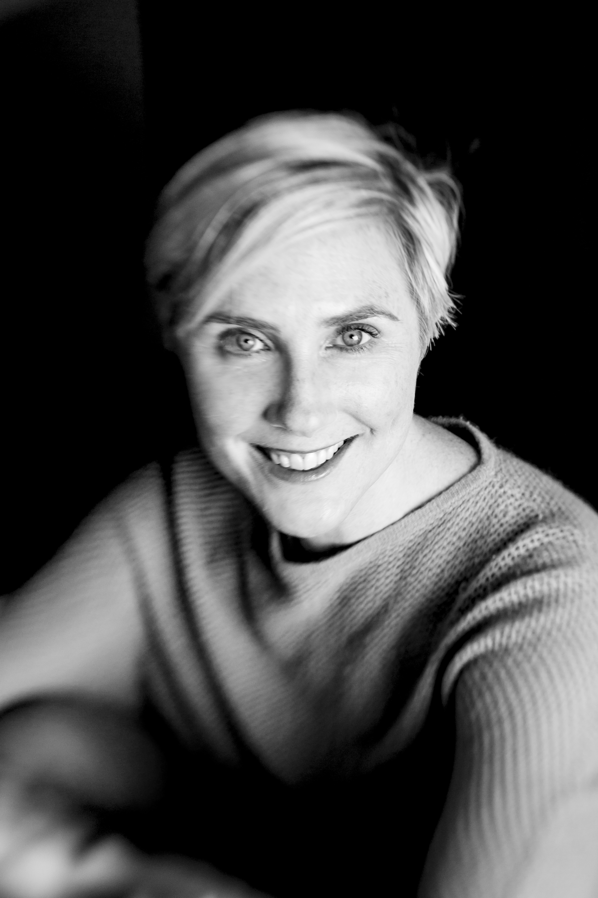
About Our Guest: Laura Holmes Haddad
Laura is a writer and speaker from Northern California. A graduate of Smith College and the California Culinary Academy. Laura was an editor at Simon & Schuster before pursuing a freelance writing career. Laura’s career focus shifted when she was diagnosed with Stage IV inflammatory breast cancer at the age of 37. After completing three years of treatment, she remains cancer-free and is committed to healthcare policy and patient advocacy work. Laura travels throughout the U.S. speaking to a wide range of audiences about clinical drug trial access and cancer survivorship issues. Her speaking engagements include the “Cancer Moonshot” roundtable with Vice President Joe Biden, the American Cancer Society Cancer Action Network, Making Strides Against Breast Cancer, the University of California San Francisco Helen Diller Family Comprehensive Cancer Center, the BRCA Foundation, Pillpack.com, the Young Survival Coalition National Summit, and Blue Shield of California. She is a regular guest blogger on many patient-centered cancer websites and has appeared on numerous radio shows and podcasts. In addition, Laura is the author of This is Cancer: Everything You Need to Know, from the Waiting Room to the Bedroom (Hachette/Seal Press, 2016). Laura wrote the book to give patients and caregivers tips and strategies to help them navigate the world of cancer. Laura lives in Northern California with her husband and two children.

For more information
Twitter: @HolmesHaddad
Website: lauraholmeshaddad.com

