Dr. Selin Kurnaz of Massive Bio Explains the Need to Operationalize Patient Support in Precision Cancer Care

December 19, 2019

Karan Cushman: Welcome to the The Precision Medicine Podcast, sponsored by Trapelo. This is the podcast where experts come to discuss the problems oncologists, reference labs and payers face as precision medicine grows, and consider solutions for advancing the quality of patient-centered cancer care. Be sure to subscribe at precisionmedicinepodcast.com to get the latest episodes delivered straight to your inbox.
Jerome Madison: We're with Selin Kurnaz here and you were just a speaker on a panel that talked about precision medicine in clinical trials and novel trial designs and okay, you threw a lot of terms out there. So we had basket trials, umbrella trials, seamless trials, adaptive trial designs, just-in-time trials. How much of a change is this from the traditional randomized prospective trials and what's the purpose of shifting to these types of trials?
Selin Kurnaz: Yeah, so that's a very good question. So, the idea is that historically, you open a site for a specific clinical trial, and then you expect the patients are going to show up, and then they get enrolled into these clinical trials. So, the idea of the just-in-time site is that it's still almost open as a quasi-site, and then when that perfect patient that has been identified in that specific site, so that you activate that site. So this is a way in order to be able to bring the clinical trials to the patients as opposed to bring the patients to the clinical trials. Because the reason why we're actually spending so much time and effort on that aspect is that last month, there's about 1,100 cancer patients that come to our patient contact center. 55% of those patients, we were in a position to be able to identify the clinical trials that are feasible from a clinical feasibility standpoint.
Selin Kurnaz: However, when you look at the enrollment rate, that enrollment rate drops about 12.5%. The reason why you lose about that 75% productivity is two issues. One of them, it's the lack of ability for them to be able to find a site that is close to where their current provider is—because it's almost like a deal breaker, the moment that you ask the patient to get into a different site, in the end those are not healthy patients. Those are cancer patients. They have to change their entire, I would say, life, they have to change their environment in order to be able to be a part of that journey. So, it's very difficult for them.
Selin Kurnaz: The second issue that we are also, I would say struggling, is the insurance issue. If you are looking for like a Medicaid patient, that patient cannot travel from state to state, and they have to cover all these out-of-pocket costs that's not being covered, and that's a very huge burden, a financial burden for cancer patients in order for them to be able to get enrolled to these clinical trials.
Selin Kurnaz: So, what we're trying to show is that there has to be more policy, there has to be more innovative approaches in order to, after the clinical feasibility has been fulfilled, how to really place that patient to a clinical trial that is not going to change their life drastically, so that they can, I would say, live their life by basically understanding that there's all these other things that they have to work with the care, that the cancer that they're going through.
Jerome Madison: So greater accessibility can increase those numbers.
Selin Kurnaz: Right, sure.
Jerome Madison: You talked about the recent changes that the FDA policy that affects research and clinical trial matching. Can you talk a little bit more about that and how that has benefited?
Selin Kurnaz: So, in terms of the ... I would say, I can talk about more the Biden cancer initiative, some of the policies that has been done, because just last week at ASCO, American Society of Clinical Oncology Conference, annual conference in 2019, there was an initiative that has been launched, and the aspect of that initiative is oncology clinical trial information comments. And the reason why there's a healthy number of healthcare innovators that came into that initiative is that, so there is the aspect of the medical records, the next-generation sequencing results to structure that information, but there is also an aspect of the ClinicalTrials.gov. If you are a person in the world of clinical trials, there is no way to detach yourself from the ClinicalTrials.gov, and the issue with the ClinicalTrials.gov right now is that that information is not structured in order to be able to match or prescreen the patients for clinical trials.
Selin Kurnaz: That information was for the pharmaceutical companies to post their clinical trials to the public. That was never meant to have a very specific use case. So, because of that reason, those institutions came together in order to be able to structure that information, so that if will be more accessible by the patients and by the healthcare providers to be able to sift through that ClinicalTrials.gov, because right now there's about 11,000 clinical trials at the ClinicalTrials.gov just for oncology. It's like overwhelming amount.
Selin Kurnaz: Then the other thing that we are trying to do is that for future clinical trials, how we are going to be able to develop the framework so that the pharmaceutical sponsor will follow that framework. They input that information, that framework, it's also get populated to the ClinicalTrials.gov so that we can standardize, we can structure, and scale that access of the patients to the ClinicalTrials.gov and all the peripheral information that's associated with that.
Jerome Madison: That in some part reflects the work that you guys do at Massive Bio.
Selin Kurnaz: Correct.
Jerome Madison: So, I may have mentioned, you're CEO of Massive Bio, tell us a little bit more about the work you do, and you mentioned structuring unstructured data. What is the work that you guys do with that and then what is your goals?
Selin Kurnaz: Sure, sure. So, Massive Bio in big picture, we are a marketplace that connects the cancer patients as well as their treating oncologist with cutting edge clinical trials as well as advanced care plans. So, if you're in a cancer patient, that is in a more ... like a remoter location, that you may not have access to a glorified, large, academic medical cancer center…as we all know that cancer does not discriminate. You can go into any socioeconomic condition but you still get cancer.
Selin Kurnaz: So, we are trying to enable that all these fascinating, cutting-edge science that's happening in the oncology to the patient’s point of care, wherever that they're located and wherever their insurance situation is.
Selin Kurnaz: There are two core competencies that we are bringing to the table. One of them is by patient acquisition channels. The other one is exactly how you are saying, how we're in a position to be able to structure that unstructured information and there are three different types of that:
Selin Kurnaz: There is the medical records, there is the biomarker-based testing, NGS testing results, and there is also the clinical trials, because you need to have a pitcher and a catcher relationship in the clinical trial pre-screening because it doesn't just matter that you structured the medical information, you also need to structure the ClinicalTrials.gov information, or any kind of the clinical trial protocol information in order to be able to have that pre-screening. The last thing that we also put a very, very strong emphasis is on the operationalization support, which is the last mile.
Selin Kurnaz: How are we going to be able to enable a patient to be able to have a site that is close to their environment? How can we have a just-in-time site? How are we going to be able to develop escalation process to pharma so that they can cover the out-of-pocket costs that the patient cannot be able to do that?
Jerome Madison: Very important.
Selin Kurnaz: Those are the, I would say, things that are I think hugely overlooked in our industry. We get so much excited if there's a new molecule. We get so much excited when we see data and technology, because those are the sexy and the fun things. However, we also need to get excited about the hard work, which is that resolving the issues in the last mile, opening up the enrollment channel to these cancer patients, because in the end that's when it matters.
Jerome Madison: So, the conversation at ASCOC was stemming from how do we make these disparate pieces of information more dynamic?
Selin Kurnaz: Correct.
Jerome Madison: How do we pull them together? And that's the conversation that you just had here at the Precision Medicine Leadership Summit of how to leverage that data, Omics, artificial intelligence and policy. Is it a large ask? How far in the foreseeable future do you see those things coming together and making us better? What do we do?
Selin Kurnaz: Yeah. I always say we cannot finish if we don't start, that we understand that there is a monumental problem that is in front of us. The good news is that I think this is not an uncontrollable problem. This is a controllable problem, but we have to admit and understand is that majority of the problem, it's an operational problem and a policy problem, because we do not have a centralized healthcare system in the United States. Since there are all these private enterprises that are doing whatever that they feel that's the right thing to do, you are not going to completely stop these, I would say, proliferation in the data in somebody else's backyard, okay? But there are ways in order to be able to make this data more accessible, more streamlined, more use-case oriented so that we need to, I would say, disposition the investment and we need to disposition, I would say, these policies in such a way that that can enable that to us.
Selin Kurnaz: I am optimistic. I am, of course, optimistic but I am also, I would say, trying to educate the industry that we know that there is a problem but we have to make sure that we are solving the right problem, and that we are also making sure that these are all use-case oriented as well as it creates this very tangible outcome to the cancer patient, so that we are not solving these problems in order to solve a mathematical problem, or in order to make ourselves rich, or in order to make ourselves famous, so that it gets directed to the bottom line of the patient what they need to do from a clinical-trial standpoint, or in terms of the, I would say, advanced care plan standpoint.
Selin Kurnaz: So, there is a light at the end of the tunnel, but we need to start with small victories. We have to show, I would say, both the clinical case as well as business case, and we need to marry that with the right policy and the governance structure so that it can be scaled. And then it can basically get access to every cancer patient deserves because there is 1.7 million cancer patient that's been diagnosed with cancer last year in the United States.
Jerome Madison: Well, it seems obvious with what you're talking about with the work that you guys do at Massive Bio, collaboration is the key.
Selin Kurnaz: Right.
Jerome Madison: Thank you for joining us.
Selin Kurnaz: Absolutely, it's a pleasure. Thank you very much for your time and thank you very much for having me.
Karan Cushman: You've been listening to the Precision Medicine Podcast sponsored by Trapelo. Trapelo is the first clinical decision support tool to align the interests of oncologist labs and payers to give patients the best chance at beating cancer. To learn more, visit gettrapelo.com. To subscribe to the podcast or download transcripts of any episode. Visit precisionmedicinepodcast.com. We invite you to join the conversation on social media. You can find us on Twitter at PMPbyTrapelo, or on LinkedIn at the Intervention Insights company page. If you know someone who would enjoy the Precision Medicine Podcast, please share it. They'll thank you and so will we. We hope you'll tune in for the next episode.

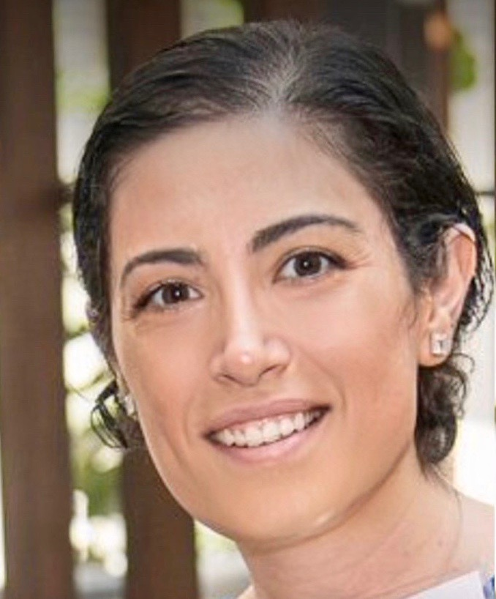

About Our Guest: Selin Kurnaz, PhD
Dr. Kurnaz is the Lead Founder and CEO of Massive Bio, Inc.
After emigrating from Turkey and completing a PhD at the University of Michigan, receiving multiple engineering degrees, Selin spent more than a decade specializing in delivering revenue enhancement, margin optimization and capital efficiency improvements for Healthcare and Life Science companies. Selin was one of the co-founders of EY’s Private Equity Value Creation before she has experienced a family situation in cancer. Then, she founded Massive Bio to de-bottleneck the access issues between cutting edge cancer treatments and cancer patients that are predominantly treated at community practices.
Selin has engaged multiple stakeholders (patients, oncologists, payers, and pharmaceutical companies), coordinated observational studies, and optimized clinical workflows. Selin has written and spoke extensively about the optimization of artificial intelligence, operations and value added services to disrupt clinical trial enrollment value chain. Massive Bio is an alumni of eLab and PhilipsHealthworks Precision Cancer Care start-up acceleration programs.

