SEASON TWO
Dr. John Quackenbush on Embracing Biological Complexity to Realize the Potential of Precision Medicine

March 29, 2020

Karan Cushman: Welcome to Season Two of the Precision Medicine Podcast sponsored by Trapelo. This is the podcast where experts come to discuss the problems oncologists, reference labs, and payers face as precision medicine grows and consider solutions for advancing the quality of patient centered cancer care. Be sure to subscribe at precisionmedicinepodcast.com to get the latest episodes delivered straight to your inbox.
Jerome Madison: Welcome to another episode of the Precision Medicine Podcast. I'm Jerome Madison, vice president at Trapelo and today we have John Quackenbush, PhD, chair of the department of biostatistics at Harvard University's T.H. Chan School of Public Health. So we've been talking about your work on the genome, and the structure and the way that the genome is expressed, which is influenced by a number of factors that make a protein product, which makes us all different. I remember when NGS was launched. I guess before then, there were a lot of biomarker studies, and they were correlative biomarker studies, for protein expression. But as NGS was launched, gene expression started to be looked at as an outdated technology or insignificant information.
Jerome Madison: But now I hear more experts in the field, again talking about the importance of gene expression or proteomics. Because as I've heard it stated, the end result of a gene aberration is that a protein is made or not made, which may create an abnormality that can eventually become disease. When you consider your models for computational biology and the components of the genome, how important is protein expression when we're making decisions on how to treat and evaluate patients?
John Q: So we do a lot more work with genome sequence data. And we do a lot more work with RNA-Seq data than we do with proteins, just because proteins are harder to measure. I tend to think about this... Why does everybody chase genome sequencing after the introduction of next generation sequencing technologies. Scientists are often like cats, we chase the bright shiny objects, right? So if we have a new technology, a lot of people tend to jump on that technology, because it provides the opportunity to capture much more data. But we now use that same kind of next generation sequencing technology to look at gene expression by doing RNA sequencing. While as 10 years ago we would've been using DNA micro arrays, which now people often consider an outdated technology.
John Q: But why is RNA sequencing important, why is protein expression important? And the analogy I like to give to that goes back to my training in physics. I tend to think about the genome being like potential energy. So if you have a ball on top of a hill, that ball has a lot of energy because it's high up. It's at a high altitude. But what that ball does at the top of the hill is going to depend on how it rolls, right? If it rolls down a shallow slope, it's going to pick up speed slowly. If rolls down a steep slope, it's going to pick up speed quickly. And that rolling energy is what we call kinetic energy.
John Q: And the genome in some way represents the potential energy. It's the potential that the cell has to do something. But when that potential energy is put into action, when the program and the genome is actually put into action and carried out, it's first enacted through the activity of RNA.
John Q: So we can do gene expression analysis, right? Look at the relative levels of different RNA as representing different genes. And ultimately when the rubber hits the road, when the function really gets carried out, that's when we make these proteins. And so, ultimately it would be great to have information about the DNA, information about the RNA, information about the proteins. Today we have a lot more information about DNA and RNA than we do about proteins. But people like me and my colleagues, we're always trying to develop new methods to take the available data we have and get as much out of it as we can. And then also to try to link out and understand that there's something we call the central dogma in molecular biology. DNA gets translated to RNA, gets transcribed to make proteins.
John Q: And if we look at this in the broader picture, there are a lot more elements in the cell that contribute to carrying out this process and act downstream and upstream of the DNA and the proteins. But if we really think about the central process, we recognize that each data type in and of itself only gives us part of the picture. and that's the beauty of biology. We've evolved over millions of years to have a biology and processes that are robust and stable and work together. And part of what keeps them stable is this beautiful complexity. And while it's really attractive in a way to try to take everything and boil it down to a gene or boil it down to a protein, if we can embrace this complexity and the beautiful complexity of biological systems, it really gives us interesting opportunities to understand more about what makes us, us. And what goes wrong when our cells develop dysfunction like they do in cancer.
Jerome Madison: Yeah. In the talk that you recently gave, it was titled Complexity Beyond Simple Mutations. You showed a slide that the sales forces, in the early days of selling precision medicine testing tools, used very effectively of the high cost of non-responders. And very quickly for our listeners, if you have a cancer drug that costs $1 million and it's only a 30% response rate, that's essentially $700,000 in ineffective therapy being paid for. Dr. Vincent DeVita, very much a pioneer in modern oncology, noted in Principles and Practices of Oncology that the primary reason for cancer treatment failure is drug resistance. And if that's the case, it seems that there's such an investment on pinpointing targets that are a positive predictive value or response. But it would seem to be an even bigger opportunity to find oncogenes or targets to help us de-select therapy to avoid excessive toxicity and costs. Why do you think researchers are not looking at that more? Are they looking at that more, and why don't we hear about that conversation even more?
John Q: I think there are a lot of reasons for this. One of the interesting things about cancer is that it's unlike almost any other disease. If you have heart disease, you go to your physician and say, fix my heart. If you have cancer, you say get it out of me. And one way to get it out is to do surgery. Another way to get it out, though, is to develop drugs like a lot of the chemotherapy drugs that we use, that actually try to target specific aspects of cancer cells to kill those cancer cells. So we're playing this interesting game in cancer where we're using toxic compounds as a tool to try to cure patients. And a big part of the reason why so much chemotherapy causes all these side effects is that the toxicity of these compounds is often directed toward rapidly dividing cells, which is one of the hallmarks of cancer cells growing out of control.
John Q: And so they do have broad-based side effects that we'd like to try to eliminate. A big part of the move to precision medicine has been to identify specific mutations in what we think of is drivers of cancer, oncogenes and tumor suppressor genes. These genes that really help push cancer along to develop from an otherwise healthy cell. And these are often mutations we pick up over the course of our lifetime. They're not mutations that we're born with. And so the idea behind a lot of precision medicine is that we can find mutations that are unique to cancer. And we can develop drugs that will target those particular mutations. And when I say those mutations, I generally mean target the proteins. Going back to the discussion we had earlier, targeting the proteins that are encoded by those genes. So it's a really attractive proposition. We can avoid killing or hurting the healthy cells by finding mutations in genes that are going to encode proteins that will drive cancer.
John Q: But those mutations aren't going to be in most of the healthy cells. Now it's a great idea, but part of the challenge that we faced is that, like we were talking about earlier, it's not just single proteins acting by themselves or single genes acting by themselves. They're acting in these complex networks, and there are other processes at play in the cell. There are drug metabolism processes, there are processes that excrete drugs from within the cell. So there are all these different competing activities happening, right? The drug is trying to kill the cell. The cell itself is trying to react and stay alive. And because tumor cells are growing so rapidly, what happens is they have a tendency to accumulate new mutations that often allow them to escape the effects of the drug. So if we take a very reductionist approach and look at individual genes, individual proteins and individual drugs, we can understand how so many tumors can escape.
John Q: But if we think about it in this broader context of these different pieces working together to keep the tumor cell alive, right, and they've evolved for millions of years to keep healthy cells alive. To keep the tumor cell alive, we can understand why so many drugs fail, or why so many drugs have a limited amount of effectiveness, either in the population in which they work or the time over which they work. And so we can start to think about building better models to predict who's going to respond and when. So you asked the question, have we started to look for different genetic variants that can help direct therapy in an intelligent way? And the answer is yes. We've started to discover some of those. So again, a lot of the easiest ones to talk about are simple mutations.
John Q: But in colon cancer, for example, if your tumor has a mutation in a gene called KRAS, there's a whole set of drugs, EGFR inhibitors, that we would say are unlikely or less likely to work in someone who carries that mutation than someone who doesn't. And so, again, the great thing about living today and having access to technologies that allow us to sequence genomes for $1,000 or less, is that we can really start to think about building up a compendium of data that, by using computational tools, we can start to mine to identify who's going to respond and who isn't. So it's this time when I think we're going to constantly get better at what we do by pulling out new insights, and then developing strategies to take those insights from the lab or from the laptop into the clinic.
Jerome Madison: Yeah. John Quackenbush, PhD, Chair of the Department of Biostatistics at Harvard University. This has been a treat and I will say to commend you, this is probably the lowest level talk I've ever heard you give and I appreciate it so much. This is so chock-full of rich information. So I hope you listeners would come back and revisit this because there's so much in there. And follow him on social media. You're active on Twitter and other social media platforms. Can you give them your Twitter account so they can follow you?
John Q: Sure. It's just @johnquackenbush, all one word. Thank you very much. I just wanted to say thank you for the kind words. One of the things I really like doing is talking about my work. And I always try to explain it the way I actually think about it. I always find if you can think about things in very simple ways, you can often see a lot more into the problem than if you hide it behind a lot of jargon. So I'm glad I did a good job of explaining what I do.
Jerome Madison: It's remarkable. And so if you guys have ever heard John Quackenbush talk, he uses quotes in his presentations. And I'll never forget this quote because you were giving this talk with an enormous amount of brilliant people in the room. But it was very spot on. The quote was, "Before I heard you speak, I was very confused about this topic. But after hearing you speak, I'm still confused, but at a much higher level." But that didn't happen on this podcast. And I thank you for really coming on and explaining your work. And it's been a real treat to have you on as a guest.
John Q: It was my pleasure and I think the, the quote belongs to Enrico Fermi, so I don't deserve credit for that. But I hope no one is confused at a higher level. But if they are, I'd love to hear questions.
Jerome Madison: Thanks so much.
John Q: All right, take care and thank you for having me, Jerome.
Jerome Madison: You bet.
Karan Cushman: You've been listening to the precision medicine podcast sponsored by Trapelo. Trapelo is the first clinical decision-support tool to align the interests of oncologist, labs, and payers to give patients the best chance at beating cancer. To learn more, visit gettrapelo.com. To subscribe to the podcast or download transcripts of any episode, visit precisionmedicinepodcast.com.
Karan Cushman: We invite you to join the conversation on social media. You can find us on Twitter at PMPbyTrapelo or on LinkedIn at the Intervention Insights company page. If someone who would enjoy the Precision Medicine Podcast, please share it. They'll thank you, and so will we. We hope you'll tune in for the next episode.

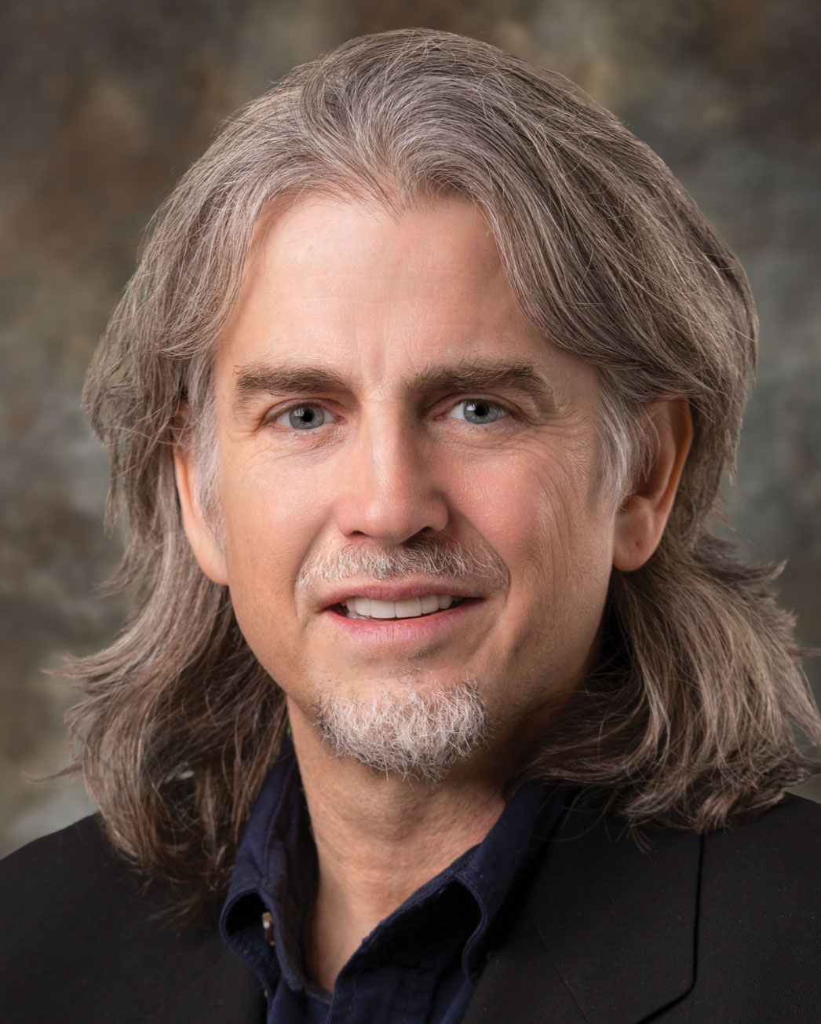

About Our Guest: John Quackenbush, Ph.D.
John Quackenbush is Professor and Chair in the Department of Biostatistics at the Harvard TH Chan School of Public Health. John’s Ph.D. was in Theoretical Physics, and he received a Human Genome Project fellowship in 1992. This led him through the Salk Institute, Stanford University, The Institute for Genomic Research (TIGR), and then to Harvard in 2005. John uses massive data to probe how many small effects combine to influence health and risk of disease. His work has been cited more than 70,000 times. Among his honors is recognition as a White House Open Science Champion of Change, which he received in 2013.

