EPISODE ELEVEN:
Can Collaboration Ease the Burdens of Prior Authorization in Precision Medicine Today?

Clynt Taylor, CEO Intervention Insights | March 27, 2019
Welcome to The Precision Medicine Podcast, where experts come to discuss the problems oncologists, reference labs, and payers face as precision medicine grows, and consider solutions for advancing the quality of patient-centered cancer care.
Jerome Madison: Welcome to the Precision Medicine Podcast. I'm Jerome Madison, vice president of provider relations with Trapelo, and one of the hosts of the Precision Podcast. Today, we're excited to have one of the other hosts of the Precision Medicine Podcast, the CEO of Trapelo, Clynt Taylor.
Clynt, I'm excited to have you on, and I'm very thankful to have you on, along with a lot of our regular listeners, because you in large part make this podcast possible, along with our producer Karan. So thank you, and welcome to the podcast.
Clynt Taylor: Thanks Jerome. Glad to be on.
Jerome Madison: Tell us a little bit about your background and what has attracted you into the space of precision medicine.
Clynt Taylor: Sure.
Well, I started my career out of college with IBM in healthcare marketing, and I've really been involved in some kind of healthcare technology for a long time. With the exception of a couple of sabbaticals, I've been involved with this since then. I developed a love for it really early, and I just really enjoy it.
Once I left IBM, I joined an electronic medical record startup called NextGen, at the time it was called Clinitec. I got to be a part of that as electronic medical records were first coming onto the scene. It was a great experience. And I've really been involved with various healthcare technology startups and/or early companies, innovative companies, since then.
But in 2008, I was introduced to Patrick Soon-Shiong. Many people know Dr. Soon-Shiong. I was one of the early people that he brought on to help him realize his goals for using technology in healthcare. I had the opportunity, in 2009, to be part of one of the companies that he acquired, which was, at the time, called ITA Partners. They were doing retrospective case reviews for oncology cases, and wanted to take that database they had built and make it much more usable in decision support.
Clynt Taylor: So we relaunched that company called eviti, and that really is where I got involved in the oncology decision support space. And that was, like I said, in 2009. I had the opportunity while I was working with eviti, and soon thereafter, to help in the launch of GPS Cancer, which is a really cool, innovative test that NantHealth had introduced. It gave me the introduction to the challenges that labs face.
And then from there, I was invited to join Intervention Insights in precision medicine. And you asked me what really attracted me to precision medicine. I have to say it wasn't specifically precision medicine, but I'm really motivated by improving the patient care experience. And I think that's what's drawn me or pulled me into new innovative areas in healthcare my whole career.
If it can improve the patient care experience, I'm fascinated by it, and I'm impassioned to be a part of it. And I really believe that precision medicine is the future of not just cancer care, but a lot of diseases. And so I am super motivated to be doing what we're doing today. I consider it a great privilege, working with the kinds of people that are dedicated, really dedicated to finding answers and leveraging precision medicine to help patients.
Jerome Madison: Yeah.
You mentioned your background. You've been with a lot of startups. You are entrepreneurial spirited. You’ve created new technologies, you've launched new technologies. How important is it to be working with people who share that entrepreneurial drive in creative critical thinking when you're building companies?
Clynt Taylor: Well, it's huge. And you've heard me say this, but I really believe that more than any other industry, healthcare requires collaboration to really innovate. There are so many diverse perspectives and even competing priorities. So you have to have teams of people that are willing to listen, willing to try new things, willing to take on big challenges. And in healthcare, some of these challenges are daunting. You look at it and say, "Can you even fix this problem?"
So we really do have to have people that are passionate about that. And what I found is that if the patient stays at the center of it, then you never really get discouraged, because you never lacked purpose, you never lack a real reason for doing what you're doing. And even in areas where you're building technology, there's still a very important role for remembering the reasons we're doing it, which is really to improve the whole patient experience.
Jerome Madison: For sure.
Jerome Madison: And the reason why I asked that question is when you arrived at Intervention Insights, it was not the company that it is today, and Trapelo didn't exist, but how did your vision evolve to focus on the problem of prior authorization? Because, as you said, it takes someone who's innovative and forward thinking to tackle such a big problem. But how did your vision evolve to tackle prior authorization, and why is it such a big problem in healthcare?
Clynt Taylor: Well, when I got to Intervention Insights, the team here had already built this really, really incredible knowledge base of precision medicine, where genes and drugs and diseases and all the clinical evidence that supports any of those associations, and they were trying to do that. They had started the company in 2011 with the idea that could we create a better report that doctors and labs could use to make better treatment decisions. And that was a really good idea.
But what I learned in those years working with eviti, and in the years trying to help launch a lab test, is that doctors can go through a lot of exercise, and even really good due diligence to come up with a treatment option. And then they've got to go and sell that, often, to the health plan. And that can be a real downer. If you're a patient, and you're wanting to get started on a treatment, and you've perhaps already had testing done, and maybe you've already worked with this doctor to come up with the right plan, that's a real downer.
And I realized that if we really wanted to make a change to this, we would have to find a way to bring all the parties to the table in a real-time type of situation. And having seen that ... because the other thing, Jerome, is that when you consider labs who are trying to get their new innovations out into the marketplace, they want doctors to know that a new test has been approved, or perhaps a panel now has an extended number of genes that could be tested. And all the innovations that labs are making, they face some of the same challenges. How do I get that in front of doctors and in the mindset of doctors at the time that it needs to be used?
So all of these just began to become this big thing, I guess, where I realized that we could go and help doctors make better treatment decisions, but we wouldn't make the experience necessarily that much better if they've still got to go get a prior authorization. So we had to find some way to rethink this.
Jerome Madison: Yeah.
When you're tackling big problems like that, I know that for many people out there who are innovators in their own right, you have to have a great deal of passion. And at the leadership position, I know I'm speaking personally, it makes a big difference.
I know that you, as well as Karan and myself, we all share a personal history with cancer in our families. For me, it was my father. Can you share your experience with the cancer care journey of your father, and how that drives you to make a difference in the way patients have access to care?
Clynt Taylor: Yeah, for sure.
What's kind of interesting about this is that I've been working in this since 2009, as I mentioned, 2008 really. I had observed or taken note that while I've been all around the oncology care landscape, I hadn't had it really touch me that closely. I have had, of course, friends who have battled with cancer.
But soon after I joined Intervention Insights, and we were really looking for how do we leverage this really great platform to make a difference, I was thinking about we could take this and really help doctors make better treatment decisions, or we could help labs get reimbursed better. We could go to payers, we could sell a system directly to payers. I was really trying to scope out which stakeholder that we should be selling to, when my dad got sick.
He was diagnosed with throat cancer, and we started this journey, and I found myself ... first of all, I'm sure a lot of people have felt this ... Going into this, I would have told you, "Look, I know leading oncologists all over the country. I can call many of the leading oncologists and have a team of people assembled to help."
Clynt Taylor: But when somebody really close to you like this gets sick, it's like I'm a deer in headlights. I don't even know where to look. But as I processed this, and I traveled to Tulsa from Dallas to be with my dad almost every week in the eight or nine months that he battled with this disease, and was there full time the last six weeks with him, it gave me a lot of time to really think.
And I remember getting to a point in this process where I thought, I'm not going to pick one stakeholder. If we can't find a way to fix these problems by aligning the interests of all the stakeholders, then we are going to do a disservice, we're going to exacerbate a problem that I'm now trying to fight through, and we're going to make it tough for other patients. Because I don't want to invent or innovate a solution that just helps game everybody else. That's the wrong approach.
So we're going to take the longer road, a little bit harder road, but we're going to make a real difference. And when we're successful and we're done ... and I say we, because when I say we, it's very inclusive, it's a lot of people, not just one company even ... we're gonna make a big difference. We're gonna lead in the changes in how precision medicine gets delivered and gets to people who need it.
Jerome Madison: And the end result of that inspiration was Trapelo.
So can you share ... many of us… every single week that we release a podcast episode, we know that it's sponsored by Trapelo. They hear me talk about being the Vice President of Provider Relations with Trapelo. Tell us what is Trapelo, and how does it solve the burdens of prior authorization, as well as other complexities associated with the scale and access to precision medicine?
Clynt Taylor: Absolutely. Well, I have to say that it really is inspired by a great deal of real life experience. If we came to this, again, just saying let's bring the perspective of one party or one stakeholder, we would absolutely be missing the mark. So what we did is we looked at, and spent a lot of time with, key thought leaders, with payers and key thought leaders, oncologists.
I had the privilege of going and spending three days in an oncology practice. I have never been through some ... I've never really experienced firsthand these oncologists who are trying to read these molecular test results and trying to understand them in order to turn them into some kind of a treatment that might save this patient's life. I was able to be part of that.
And then I worked alongside labs and listened to them tell me, "Here are our problems, our challenges. How do we solve these?"
By really trying to take the time to understand everybody's perspective, I think we were able to come back and start to say, "Alright, how do we envision the way this really should work?" If we just said, "Forget some of the restrictions, the constraints for a moment, how should this work to satisfy the priorities of providers, labs and payers," what would it look like?
Clynt Taylor: I think that's really what inspired it. So to just be really practical about it, we said, "Alright, what are the problems that oncologists are facing today in the use of precision medicine?" Number one, many of them don't know what to order, who to order from, which of the tests is going to get back to me the quickest, which one will have the information that I can actually use.
And oh, by the way, as an oncologist, many oncologists today still say, "Look, I want to see the evidence that supports the different treatment options. I want to know which ones have the highest level of evidence." So that became really important.
So we said, "Alright, what if we could inform that? What if we could actually provide a resource so that oncologist could put in a little bit of information?" We could say, "Look, these are the genes that you would need to test today at a minimum to give you an actionable result, that is a result that drives to a treatment that has clinical evidence to support it. Now that doesn't mean there's not a lot of other options, but you'd want to know that first, right?"
And everybody said, "Yeah, that's what we'd want to know first. Because we might actually decide that there isn't anything that we could test for today that has clinical evidence to support it as a targeted therapy, but there are some chemotherapy regimens and some other types of treatments that might already have evidence, and we may want to go there without waiting the two weeks for testing."
Clynt Taylor: The next step is that we said, "Look, you've got all these different doctors receiving test results from different labs. How do you know that your practice is consistently ordering, and then reviewing and analyzing and interpreting the results?"
Clynt Taylor: And the answer was, "Well, you really can't, because the perspectives are different."
So we said, "What if we normalize that information for you into a single screen, and we highlighted the stuff that was really important to you? We're not going to modify the results from the test, but maybe make it a little simpler and easier and consistent."
So we realized we had doctors saying that would be huge. And then we said, "What if at the very beginning, when you got ready to order that test, we could tell you right off the bat, 'This test, because it's got a minimum set of requirements, and you're picking an optimal lab that's in the network of the provider, it's already preauthorized.' You don't even have to go get an authorization. You can send that confidently to the lab, and the lab can do the test confidently, knowing it's going to be reimbursed."
And everybody started saying, "That's ideal."
"And what if we baked it into the EMR, so that you can actually access it from inside an EPIC or one of the other electronic medical records systems that are being used out there, and we actually minimized keystrokes, lessen the number of keystrokes instead of increasing them?"
And that's really what we started to do when we started to envision the way this should work with Trapelo. And we did the same thing from the payer perspective. “What if you don't have to have somebody log into your system, re-enter data?” What we learned when we talked to payers is that 20% of the data that gets input through prior authorization solutions is mistyped. That leads to burden, delays, errors, etc.
“What if we eliminated a lot of that by electronically transmitting that information directly out of the workflow from the practice?” All the payers we've talked to said, "Well that is where it should evolve too. That's exactly where it should go."
And we said let's build it. That's really the way this happened. And we talked to labs and we said, "How do you get your information to doctors?"
And they said, "It's tough. We've got to go and call on them, and we got to promote it."
Clynt Taylor: We said, "What if we presented it each time?" And it was, again, the same kind of thing.
Clynt Taylor: That's how it evolved, Jerome. We basically had to go to each one of them and say, "Alright, now how do we build this in a way that doesn't hurt one, but really creates a benefit for all?"
Jerome Madison: And in my experience in the industry ... I know this is an issue with the clients that I've worked with over the years. I'm native to the genomic testing market, being at the first company that had an offering. And today ... of course, Clynt, you know this, but for the benefit of our listeners, I talk about being the Vice President of Provider Relations ... that means going in to engage cancer centers and central labs, genomic testing laboratories, to provide the solution.
And as a result, we've seen a trend happen to where some of the most innovative leading cancer centers in the country have caught on first. And while we're working with many of them, Google our partnership with City of Hope – one of the leading oncology centers on the West Coast, and certainly innovators in what they do.
Can you talk a little bit about why City of Hope saw Trapelo as a valuable resource, and how it's going to be used across their network?
Clynt Taylor: Sure.
One of the challenges that City of Hope, like probably every other major cancer center faces, is that, number one, they've got to keep up with all of the changes that are happening, those that are being published and those that are making it in the mainstream because there's clinical evidence to support it. We do that really well. That's, of course, what we do. But they also need the ability to be leading in research. And many of these have huge investments in research.
So what I think City of Hope saw ... because we had taken this into consideration when we developed Trapelo, which was we need to develop a transparent, configurable platform, open, that can be used in lots of situations. And one of the things that I know was very important to them is that they wanted to be able to see what is quote-unquote standard of care, what does the clinical evidence say.
And then when the evidence runs out, you're dealing with those more obscure or rare cases where there just isn't enough evidence, but they've perhaps got research going on, they needed a knowledge set, and a place to be able to capture, store and use that across their network. And that was one of the key things that attracted them to it, I think, was the fact that it's open, it's transparent in the way that we put information in, and it's very configurable.
Clynt Taylor: Having done technology solutions previously, I knew that we had to make this very modular. Not every group is going to want everything we do. So we had to modularize it so that we could put it into and embed it into certain workflows. So that was the other thing. Could we access this from inside EPIC? That was hugely important.
Clynt Taylor: Another thing for them is they have a big investment in their own labs. They want to be able to drive ... when it's appropriate, they want to be able to move and drive testing to their own labs. They want to be able to tell oncologists in their network, "We offer this test at our lab."
We quickly were able to go and scope out for them how we would integrate directly into their own reporting engine. So they had built their own molecular testing reporting capabilities, and we were able to show them how we designed our solution to be able to compliment that, not obsolete the work that they had done.
The same is true for research. When we got to the research department at City of Hope, and we started sharing with them our vision for being able to bring together the diagnosis information, along with the results from the molecular test, we merged that together instantly. And before anyone's even looked at it, that information is on that investigator's dashboard. They actually see it first, to know that there are patients that are very, very highly qualified candidates for clinical trials that they're accruing to.
So those are just a few of the things that I think really attracted City of Hope to what we're doing. And I have to tell you, it was born out of a lot of research that we did going into this to understand what are the real drivers, really the business drivers.
And I want to pause on this for just a minute, Jerome, because we are a unique blend, I think, at Intervention Insights with Trapelo, a very unique blend of scientists, medical doctors, and then guys like me, who are just passionate about solving the problems, really solving the problems.
So it brings this really cool dynamic, where sometimes the science raises its head and say, "But the science says."
And I'm like, "Yeah, but we've got to get this to patients."
And I think that balance helps us stay very pragmatic in dealing with the problems that exist today, because you and I both know we've worked at places where the vision of where things should go is really, really noble, it's really good, but then we still have today's problems. So we really try to focus in on solving problems today. How could we put something in place? And within a few months, we've really solved problems, and still put ourselves in a position to grow and evolve with the science.
Jerome Madison: We know that providers, as well as payers and labs, with sharing this message and talking about the business drivers and the complexities, it resonates with them. We see, in our conversations with them, that they see the value of Trapelo. But then there are some in the marketplace who have expressed skepticism that payers will obviate the need for prior authorization for precision medicine tools, or for that matter, anything.
Jerome Madison: But we've even brought on a great colleague, Dean Packer, who is the Vice President of Payer Relations. And in your conversations, how are insurance companies responding to the concept with participating with Trapelo?
Clynt Taylor: Well, first of all, I think it's natural for a payer to be skeptical. They're the ones ... it's like a dad, right? When a kid comes and says, "Hey, can I have one of these," or, "Can I have one of those?"
That's kind of that idea. They're always being asked to pay for something, and so it's natural that they would be skeptical. I actually really do appreciate a level of that skepticism, because it forces us to be good. It forces us to think through these like they would. We have to be able to think, "Alright, this has to pay for itself. This has to generate a return on investment, even though it is the right thing to do."
We can believe that we are right, but we have to realize that they're going to want to see how this generates a return on investment. Fortunately, we can show them that.
But I think the other thing that does get, sometimes, a bit challenging, is that it's also easy for any of us to get set in our ways. Innovation takes an effort. Thinking about how things should be, and being willing to reconsider and be innovative, it takes an effort. And sometimes we have to disrupt that status quo to get this to happen.
I will say though, that having been involved with and selling to payers for a long time, I don't think I've ever seen a time when they were more receptive than they are now to this. And one of the reasons I really believe they are is because we're able to bring the perspective of the oncologist and the payer and in the lab to the discussion.
For example, Jerome, in 2008, 2009, when prior authorization for oncology was just coming into to vogue, the idea of getting a prior authorization for a drug was ... it just seemed like a practical thing. And then over time, as those regiments became more and more complicated, and you have now multiple drugs, and you have supportive drugs, and you have multiple ways to deliver it, it became more and more burdensome and more friction laden.
And now with precision medicine, most payers I talk to recognize when I tell them the old ways of doing this simply won't scale with the use of precision medicine. We have to find a new way of doing it. In other words, this next generation cancer care's going to require next generation management of this.
Clynt Taylor: And so now, I think, more than, perhaps in previous times, payers are saying, "Yeah, let's talk about this. Because you're coming to the table with a oncology groups and labs who are already willing to participate, and now we get to participate in collaborate in something, rather than we've got to make the decision to do it, and then we're going to have to force it down the network, and the network's not going to like it."
Clynt Taylor: That story is old. That's done. The new way of doing this is going to require collaboration if we're going to really make a change.
Jerome Madison: Yeah.
Innovation is hard, but it's also exciting. So it's great to see the tide turning, not only of the providers who've turned over the years, the labs are looking for solutions, but as you said, the insurance companies are also noticing that the old way of doing things are not scalable in this era of precision medicine.
So where we are today, innovating in the space, what do you think Trapelo's impact is going to be on healthcare in the next three to five years?
Clynt Taylor: I don't want this to sound boastful, because it's not intended to be, but I am 100% sure that Trapelo is going to change the way precision medicine is delivered. We absolutely are already leading the conversation in this area. No one company can do it. It's going to be partnerships that we have, it's going to be willing groups that come along and make it happen.
But I promise you, you can go back and listen to this podcast in three to five years, and you're going to see that this was prophetic. And I only say that, not because I can see into the future, but because I've listened very carefully over the last five years to the needs of oncologists, labs, payers, and we have basically aligned a way of doing this that is so logical that it absolutely is going to be the way it's done.
We didn't have the technology to enable some of this previously though. We had to get to the place we are now. And precision medicine, because it is new and it's forcing us to rethink some of these things, is going to bring along with it new ways of doing it that are collaborative, transparent. I really believe transparency becomes the evolution of what was previously a prior authorization, permission-based type of system. So I really do believe that we're going to change that.
And here's the effect. The effect it's going to have is that instead of taking 12 steps and 4 weeks from the time some doctor thinks about precision medicine for a patient until he or she might actually be able to order that treatment, I think that's going to be cut in half or more. I think it's going to be minutes that get to make the decision, and then we've got to wait for the lab to do its thing. But cutting that kind of time out of this process is a major, major win for patients.
Clynt Taylor: Not only that, but having this kind of information available at the point of decision gives oncologist confidence, gives payers confidence, labs confidence, that we've looked at all the variables, all of the information that needs to be considered to make this decision, and it was presented in real time. We didn't have to go out of one system into another, into another. We didn't have to make a call or log into something and wait for them to give something back.
Clynt Taylor: No one we speak to ever says, "No, I really kind of like it the way it is or the way it was." Everyone recognizes, no, this is where it has to go.
And when we get enough of us all saying this is where it has to go, and we have bold and courageous organizations like City of Hope and so many others, who are already coming alongside us saying, "Yep, this is the way it should work, and we're going to be along with this with you," it makes me very, very confident that within the next three to five years we'll look back and say it's so much easier today than it was, because we've taken out some of the administrative burden that needed to come out of this, and we've paved the way, We've opened up the way for scaling the use of precision medicine in real time to make sure that patients get the treatment they need sooner, and everyone's confident that all the information that should be considered was considered at the right time.
Jerome Madison: Well, I'll tell you, I know that those out there listening, you've got to be vibrating with excitement, because my experience, Clynt, working with you and listening to your passion and vision motivates me every day to continue to do what we do.
Jerome Madison: And please continue to listen to the Precision Medicine Podcast. Clynt Taylor is an innovator in the space, such an innovator that he allows us to do this podcast. So Clynt, thank you for coming along and sharing the vision and sharing the great news of how we're creating disruption in the area of precision medicine.
Clynt Taylor: Absolutely. Thanks for having me. It was great. I love getting to tell the story, and I really appreciate this podcast, Jerome, and the people that you're having on and inviting to do this. I'm inspired every time I hear someone's story on the podcast. Thanks. Thanks a lot.
Jerome Madison: You bet.
Karan Cushman: Speaking of which, we have a theme going today I think, with our earlier guest Luba Greenwood, who spoke about the potential hub of Boston being the center of digital health, and the project she's doing with MassBio. So she hit on a lot of the same themes that you brought up, Clynt. So it's definitely exciting an time, especially in our neck of the woods in the country.
Clynt Taylor: Yeah, that's terrific. I'm glad to hear that.
Jerome Madison: Well we want to thank Clynt Taylor, our CEO here at Trapelo, and all of our listeners from joining us today. We hope you'll tune in for the next episode of the Precision Medicine Podcast. And don't forget, you can download full transcripts of today's episode at precisionmedicinepodcast.com. You can also follow us on Twitter at PMPbyTrapelo. That's P-M-P-B-Y-T-R-A-P-E-L-O.
If you enjoyed this episode, you probably know someone else who would too. So please tell them. They'll thank you, and so will we.

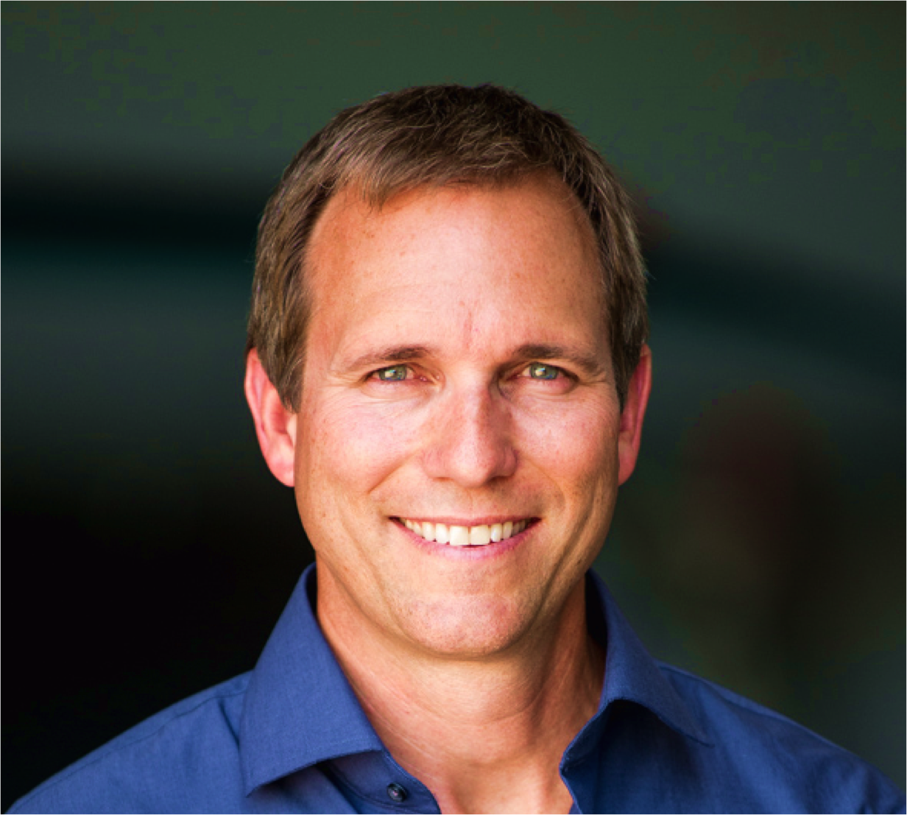

About Our Guest
​

Clynt Taylor

Chief Executive Officer of Intervention Insights

Clynt Taylor is the Chief Executive Officer of Intervention Insights and a member of the company’s board of directors. He joined Insights in 2017 and brings over 20 years of experience in healthcare technology innovation, both as an entrepreneur and senior executive with startup and growing companies.

Since beginning his career at IBM, he’s held leadership roles at healthcare technology companies like NextGen, where he led sales and marketing teams; HealthVision as General Manager of its fastest growing division (purchased by Lawson) and Galvanon as Co-founder and CEO Healthcare Solutions (purchased by NCR). Most recently, he held various senior executive roles with NantHealth - including leading the innovation, launch and commercialization of eviti, Inc., recognized today as one of the nation’s premier oncology decision support solutions. Clynt is married with four children and lives in the Dallas area.

Connect:
Email: ctaylor@interventioninsights.com
Twitter: @Clyntbt

LinkedIn: Clynt Taylor

